UNITED STATES
SECURITIES AND EXCHANGE COMMISSION
Washington, D.C. 20549
FORM 10-Q
(Mark One)
☒ |  |  | QUARTERLY REPORT PURSUANT TO SECTION 13 OR 15(d) OF THE SECURITIES EXCHANGE ACT OF 1934
For the quarterly period ended March 31, 2023
OR
☐ |  |  | TRANSITION REPORT PURSUANT TO SECTION 13 OR 15(d) OF THE SECURITIES EXCHANGE ACT OF 1934
For the transition period from to
Commission file number 000-23211
CASELLA WASTE SYSTEMS, INC.
(Exact name of registrant as specified in its charter)
Delaware |  |  | 03-0338873
(State or other jurisdiction of  incorporation or organization) |  |  | (I.R.S. Employer  Identification No.)
25 Greens Hill Lane,
Rutland, |  |  | Vermont |  |  | 05701
(Address of principal executive offices) |  |  |  |  |  | (Zip Code)
Registrant’s telephone number, including area code: (802) 775-0325
Securities registered pursuant to Section 12(b) of the Act:
Title of each class |  |  |  |  |  | Trading  Symbol(s) |  |  |  |  |  | Name of each exchange  on which registered
Class A common stock, $0.01 par value per share |  |  |  |  |  | CWST |  |  |  |  |  | The Nasdaq Stock Market LLC
 |  |  |  |  |  |  |  |  |  |  |  | (Nasdaq Global Select Market)
Indicate by check mark whether the registrant (1) has filed all reports required to be filed by Section 13 or 15(d) of the Securities Exchange Act of 1934 during the preceding 12 months (or for such shorter period that the registrant was required to file such reports), and (2) has been subject to such filing requirements for the past 90 days. Yes ☒ No ☐
Indicate by check mark whether the registrant has submitted electronically every Interactive Data File required to be submitted pursuant to Rule 405 of Regulation S-T (§232.405 of this chapter) during the preceding 12 months (or for such shorter period that the registrant was required to submit such files). Yes ☒ No ☐
Indicate by check mark whether the registrant is a large accelerated filer, an accelerated filer, a non-accelerated filer, a smaller reporting company, or an emerging growth company. See the definitions of “large accelerated filer,” “accelerated filer,” “smaller reporting company," and "emerging growth company” in Rule 12b-2 of the Exchange Act.
Large accelerated filer |  |  | ☒ |  |  | Accelerated filer |  |  | ☐
Non-accelerated filer |  |  | ☐ |  |  | Smaller reporting company |  |  | ☐
 |  |  |  |  |  | Emerging growth company |  |  | ☐
If an emerging growth company, indicate by check mark if the registrant has elected not to use the extended transition period for complying with any new or revised financial accounting standards provided pursuant to Section 13(a) of the Exchange Act. ☐

Indicate by check mark whether the registrant is a shell company (as defined in Rule 12b-2 of the Exchange Act). Yes ☐ No ☒
The number of shares outstanding of each of the registrant’s classes of common stock, as of April 15, 2023:
Class A common stock, $0.01 par value per share: |  |  | 50,897,927
Class B common stock, $0.01 par value per share: |  |  | 988,200

PART I.

ITEM 1. FINANCIAL STATEMENTS

CASELLA WASTE SYSTEMS, INC. AND SUBSIDIARIES
CONSOLIDATED BALANCE SHEETS
(in thousands)
 |  |  | March 31,  2023 |  |  |  |  |  | December 31,  2022
 |  |  | (Unaudited)
ASSETS
CURRENT ASSETS:
Cash and cash equivalents |  |  | $ | 60,226 |  |  |  |  | $ | 71,152
Accounts receivable, net of allowance for credit losses of $3,590 and $3,016, respectively |  |  | 95,192 |  |  |  |  |  | 100,886
Prepaid expenses |  |  | 11,627 |  |  |  |  |  | 15,182
Inventory |  |  | 14,175 |  |  |  |  |  | 13,472
Other current assets |  |  | 6,608 |  |  |  |  |  | 6,787
Total current assets |  |  | 187,828 |  |  |  |  |  | 207,479
Property, plant and equipment, net of accumulated depreciation and amortization of $1,090,951 and $1,064,756, respectively |  |  | 711,440 |  |  |  |  |  | 720,550
Operating lease right-of-use assets |  |  | 95,406 |  |  |  |  |  | 92,063
Goodwill |  |  | 274,458 |  |  |  |  |  | 274,458
Intangible assets, net |  |  | 87,712 |  |  |  |  |  | 91,783
Restricted assets |  |  | 1,972 |  |  |  |  |  | 1,900
Cost method investments |  |  | 10,967 |  |  |  |  |  | 10,967
Deferred income taxes |  |  | 23,491 |  |  |  |  |  | 22,903
Other non-current assets |  |  | 26,616 |  |  |  |  |  | 27,112
Total assets |  |  | $ | 1,419,890 |  |  |  |  | $ | 1,449,215
The accompanying notes are an integral part of these consolidated financial statements.
1

CASELLA WASTE SYSTEMS, INC. AND SUBSIDIARIES
CONSOLIDATED BALANCE SHEETS (Continued)
(in thousands, except for share and per share data)
 |  |  | March 31,  2023 |  |  |  |  |  | December 31,  2022
 |  |  | (Unaudited)
LIABILITIES AND STOCKHOLDERS' EQUITY
CURRENT LIABILITIES:
Current maturities of debt |  |  | $ | 9,274 |  |  |  |  | $ | 8,968
Current operating lease liabilities |  |  | 7,190 |  |  |  |  |  | 7,000
Accounts payable |  |  | 66,640 |  |  |  |  |  | 74,203
Accrued payroll and related expenses |  |  | 8,484 |  |  |  |  |  | 23,556
Accrued interest |  |  | 3,442 |  |  |  |  |  | 2,858
Contract liabilities |  |  | 4,146 |  |  |  |  |  | 3,742
Current accrued final capping, closure and post-closure costs |  |  | 10,991 |  |  |  |  |  | 11,036
Other accrued liabilities |  |  | 34,955 |  |  |  |  |  | 46,237
Total current liabilities |  |  | 145,122 |  |  |  |  |  | 177,600
Debt, less current portion |  |  | 577,567 |  |  |  |  |  | 585,015
Operating lease liabilities, less current portion |  |  | 62,155 |  |  |  |  |  | 57,345
Accrued final capping, closure and post-closure costs, less current portion |  |  | 105,165 |  |  |  |  |  | 102,642
Deferred income taxes |  |  | 438 |  |  |  |  |  | 437
Other long-term liabilities |  |  | 27,788 |  |  |  |  |  | 28,276
COMMITMENTS AND CONTINGENCIES
STOCKHOLDERS' EQUITY:
Class A common stock, $0.01 par value per share; 100,000,000 shares authorized; 50,898,000 and 50,704,000 shares issued and outstanding, respectively |  |  | 509 |  |  |  |  |  | 507
Class B common stock, $0.01 par value per share; 1,000,000 shares authorized; 988,000 shares issued and outstanding, respectively; 10 votes per share |  |  | 10 |  |  |  |  |  | 10
Additional paid-in capital |  |  | 663,735 |  |  |  |  |  | 661,761
Accumulated deficit |  |  | (168,372) |  |  |  |  |  | (171,920)
Accumulated other comprehensive income, net of tax |  |  | 5,773 |  |  |  |  |  | 7,542
Total stockholders' equity |  |  | 501,655 |  |  |  |  |  | 497,900
Total liabilities and stockholders' equity |  |  | $ | 1,419,890 |  |  |  |  | $ | 1,449,215
The accompanying notes are an integral part of these consolidated financial statements.

2

CASELLA WASTE SYSTEMS, INC. AND SUBSIDIARIES
UNAUDITED CONSOLIDATED STATEMENTS OF OPERATIONS
(in thousands, except for per share data)
Three Months Ended
March 31,
 |  |  |  |  |  |  | 2023 |  |  |  |  |  | 2022
Revenues |  |  |  |  |  |  | $ | 262,595 |  |  |  |  | $ | 234,027
Operating expenses:
Cost of operations |  |  |  |  |  |  | 180,243 |  |  |  |  |  | 162,455
General and administration |  |  |  |  |  |  | 35,679 |  |  |  |  |  | 29,793
Depreciation and amortization |  |  |  |  |  |  | 33,435 |  |  |  |  |  | 29,428
Expense from acquisition activities |  |  |  |  |  |  | 2,863 |  |  |  |  |  | 2,043
Southbridge Landfill closure charge |  |  |  |  |  |  | 110 |  |  |  |  |  | 140
 |  |  |  |  |  |  | 252,330 |  |  |  |  |  | 223,859
Operating income |  |  |  |  |  |  | 10,265 |  |  |  |  |  | 10,168
Other expense (income):
Interest income |  |  |  |  |  |  | (684) |  |  |  |  |  | (40)
Interest expense |  |  |  |  |  |  | 6,959 |  |  |  |  |  | 5,204
Other income |  |  |  |  |  |  | (349) |  |  |  |  |  | (144)
Other expense, net |  |  |  |  |  |  | 5,926 |  |  |  |  |  | 5,020
Income before income taxes |  |  |  |  |  |  | 4,339 |  |  |  |  |  | 5,148
Provision for income taxes |  |  |  |  |  |  | 791 |  |  |  |  |  | 958
Net income |  |  |  |  |  |  | $ | 3,548 |  |  |  |  | $ | 4,190
Basic earnings per share attributable to common stockholders:
Weighted average common shares outstanding |  |  |  |  |  |  | 51,770 |  |  |  |  |  | 51,490
Basic earnings per common share |  |  |  |  |  |  | $ | 0.07 |  |  |  |  | $ | 0.08
Diluted earnings per share attributable to common stockholders:
Weighted average common shares outstanding |  |  |  |  |  |  | 51,869 |  |  |  |  |  | 51,657
Diluted earnings per common share |  |  |  |  |  |  | $ | 0.07 |  |  |  |  | $ | 0.08
The accompanying notes are an integral part of these consolidated financial statements.

3

CASELLA WASTE SYSTEMS, INC. AND SUBSIDIARIES
UNAUDITED CONSOLIDATED STATEMENTS OF
COMPREHENSIVE INCOME
(in thousands)
Three Months Ended
March 31,
 |  |  |  |  |  |  | 2023 |  |  |  |  |  | 2022
Net income |  |  |  |  |  |  | $ | 3,548 |  |  |  |  | $ | 4,190
Other comprehensive income (loss), before tax:
Hedging activity:
Interest rate swap settlements |  |  |  |  |  |  | 1,055 |  |  |  |  |  | (1,163)
Interest rate swap amounts reclassified into interest expense |  |  |  |  |  |  | (1,106) |  |  |  |  |  | 1,128
Unrealized (loss) gain resulting from changes in fair value of derivative instruments |  |  |  |  |  |  | (2,391) |  |  |  |  |  | 8,381
Other comprehensive (loss) income, before tax |  |  |  |  |  |  | (2,442) |  |  |  |  |  | 8,346
Income tax (benefit) provision related to items of other comprehensive (loss) income |  |  |  |  |  |  | (673) |  |  |  |  |  | 2,203
Other comprehensive (loss) income, net of tax |  |  |  |  |  |  | (1,769) |  |  |  |  |  | 6,143
Comprehensive income |  |  |  |  |  |  | $ | 1,779 |  |  |  |  | $ | 10,333
The accompanying notes are an integral part of these consolidated financial statements.

4

CASELLA WASTE SYSTEMS, INC. AND SUBSIDIARIES
UNAUDITED CONSOLIDATED STATEMENTS OF
STOCKHOLDERS' EQUITY
(in thousands)

 |  |  |  |  |  |  |  |  | Casella Waste Systems, Inc. Stockholders' Equity
 |  |  |  |  |  |  |  |  | Class A  Common Stock |  |  |  |  |  |  |  |  |  |  |  | Class B  Common Stock |  |  |  |  |  |  |  |  |  |  |  | Additional Paid-In Capital |  |  |  |  |  | Accumulated Deficit |  |  |  |  |  | Accumulated Other  Comprehensive Income
 |  |  | Total |  |  |  |  |  | Shares |  |  |  |  |  | Amount |  |  |  |  |  | Shares |  |  |  |  |  | Amount
Balance, December 31, 2022 |  |  | $ | 497,900 |  |  |  |  | 50,704 |  |  |  |  |  | $ | 507 |  |  |  |  | 988 |  |  |  |  |  | $ | 10 |  |  |  |  | $ | 661,761 |  |  |  |  | $ | (171,920) |  |  |  |  | $ | 7,542
Issuances of Class A common stock |  |  | — |  |  |  |  |  | 194 |  |  |  |  |  | 2 |  |  |  |  |  | — |  |  |  |  |  | — |  |  |  |  |  | (2) |  |  |  |  |  | — |  |  |  |  |  | —
Stock-based compensation |  |  | 1,976 |  |  |  |  |  | — |  |  |  |  |  | — |  |  |  |  |  | — |  |  |  |  |  | — |  |  |  |  |  | 1,976 |  |  |  |  |  | — |  |  |  |  |  | —
Comprehensive income:
Net income |  |  | 3,548 |  |  |  |  |  | — |  |  |  |  |  | — |  |  |  |  |  | — |  |  |  |  |  | — |  |  |  |  |  | — |  |  |  |  |  | 3,548 |  |  |  |  |  | —
Other comprehensive loss:
Hedging activity |  |  | (1,769) |  |  |  |  |  | — |  |  |  |  |  | — |  |  |  |  |  | — |  |  |  |  |  | — |  |  |  |  |  | — |  |  |  |  |  | — |  |  |  |  |  | (1,769)
Balance, March 31, 2023 |  |  | $ | 501,655 |  |  |  |  | 50,898 |  |  |  |  |  | $ | 509 |  |  |  |  | 988 |  |  |  |  |  | $ | 10 |  |  |  |  | $ | 663,735 |  |  |  |  | $ | (168,372) |  |  |  |  | $ | 5,773

 |  |  |  |  |  |  |  |  | Casella Waste Systems, Inc. Stockholders' Equity
 |  |  |  |  |  |  |  |  | Class A  Common Stock |  |  |  |  |  |  |  |  |  |  |  | Class B  Common Stock |  |  |  |  |  |  |  |  |  |  |  | Additional Paid-In Capital |  |  |  |  |  | Accumulated Deficit |  |  |  |  |  | Accumulated Other  Comprehensive Income (Loss)
 |  |  | Total |  |  |  |  |  | Shares |  |  |  |  |  | Amount |  |  |  |  |  | Shares |  |  |  |  |  | Amount
Balance, December 31, 2021 |  |  | $ | 422,457 |  |  |  |  | 50,423 |  |  |  |  |  | $ | 504 |  |  |  |  | 988 |  |  |  |  |  | $ | 10 |  |  |  |  | $ | 652,045 |  |  |  |  | $ | (224,999) |  |  |  |  | $ | (5,103)
Issuances of Class A common stock |  |  | 19 |  |  |  |  |  | 227 |  |  |  |  |  | 2 |  |  |  |  |  | — |  |  |  |  |  | — |  |  |  |  |  | 17 |  |  |  |  |  | — |  |  |  |  |  | —
Stock-based compensation |  |  | 2,241 |  |  |  |  |  | — |  |  |  |  |  | — |  |  |  |  |  | — |  |  |  |  |  | — |  |  |  |  |  | 2,241 |  |  |  |  |  | — |  |  |  |  |  | —
Comprehensive income:
Net income |  |  | 4,190 |  |  |  |  |  | — |  |  |  |  |  | — |  |  |  |  |  | — |  |  |  |  |  | — |  |  |  |  |  | — |  |  |  |  |  | 4,190 |  |  |  |  |  | —
Other comprehensive income:
Hedging activity |  |  | 6,143 |  |  |  |  |  | — |  |  |  |  |  | — |  |  |  |  |  | — |  |  |  |  |  | — |  |  |  |  |  | — |  |  |  |  |  | — |  |  |  |  |  | 6,143
Balance, March 31, 2022 |  |  | $ | 435,050 |  |  |  |  | 50,650 |  |  |  |  |  | $ | 506 |  |  |  |  | 988 |  |  |  |  |  | $ | 10 |  |  |  |  | $ | 654,303 |  |  |  |  | $ | (220,809) |  |  |  |  | $ | 1,040
The accompanying notes are an integral part of these consolidated financial statements.

5

CASELLA WASTE SYSTEMS, INC. AND SUBSIDIARIES
UNAUDITED CONSOLIDATED STATEMENTS OF CASH FLOWS
(in thousands)
Three Months Ended
March 31,
 |  |  | 2023 |  |  |  |  |  | 2022
Cash Flows from Operating Activities:
Net income |  |  | $ | 3,548 |  |  |  |  | $ | 4,190
Adjustments to reconcile net income to net cash provided by operating activities:
Depreciation and amortization |  |  | 33,435 |  |  |  |  |  | 29,428
Interest accretion on landfill and environmental remediation liabilities |  |  | 2,510 |  |  |  |  |  | 1,966
Amortization of debt issuance costs |  |  | 502 |  |  |  |  |  | 457
Stock-based compensation |  |  | 1,976 |  |  |  |  |  | 2,241
Operating lease right-of-use assets expense |  |  | 3,328 |  |  |  |  |  | 3,162
Disposition of assets, other items and charges, net |  |  | 1,315 |  |  |  |  |  | 860
Deferred income taxes |  |  | 86 |  |  |  |  |  | 534
Changes in assets and liabilities, net of effects of acquisitions and divestitures:
Accounts receivable |  |  | 5,694 |  |  |  |  |  | 402
Accounts payable |  |  | (7,563) |  |  |  |  |  | 2,116
Prepaid expenses, inventories and other assets |  |  | 1,701 |  |  |  |  |  | (1,060)
Accrued expenses, contract liabilities and other liabilities |  |  | (30,453) |  |  |  |  |  | (19,582)
Net cash provided by operating activities |  |  | 16,079 |  |  |  |  |  | 24,714
Cash Flows from Investing Activities:
Acquisitions, net of cash acquired |  |  | (263) |  |  |  |  |  | (49,757)
Additions to property, plant and equipment |  |  | (17,879) |  |  |  |  |  | (12,910)
Proceeds from sale of property and equipment |  |  | 415 |  |  |  |  |  | 145
Net cash used in investing activities |  |  | (17,727) |  |  |  |  |  | (62,522)
Cash Flows from Financing Activities:
Proceeds from debt borrowings |  |  | — |  |  |  |  |  | 25,600
Principal payments on debt |  |  | (8,996) |  |  |  |  |  | (9,014)
Payments of debt issuance costs |  |  | (282) |  |  |  |  |  | (12)
Proceeds from the exercise of share based awards |  |  | — |  |  |  |  |  | 19
Net cash (used in) provided by financing activities |  |  | (9,278) |  |  |  |  |  | 16,593
Net decrease in cash and cash equivalents |  |  | (10,926) |  |  |  |  |  | (21,215)
Cash and cash equivalents, beginning of period |  |  | 71,152 |  |  |  |  |  | 33,809
Cash and cash equivalents, end of period |  |  | $ | 60,226 |  |  |  |  | $ | 12,594
Supplemental Disclosure of Cash Flow Information:
Cash interest payments |  |  | $ | 5,873 |  |  |  |  | $ | 4,840
Cash income tax payments |  |  | $ | 4,807 |  |  |  |  | $ | 221
Right-of-use assets obtained in exchange for financing lease obligations |  |  | $ | 1,634 |  |  |  |  | $ | 1,032
Right-of-use assets obtained in exchange for operating lease obligations |  |  | $ | 5,682 |  |  |  |  | $ | 2,710
The accompanying notes are an integral part of these consolidated financial statements.

6

CASELLA WASTE SYSTEMS, INC. AND SUBSIDIARIES
NOTES TO UNAUDITED CONSOLIDATED FINANCIAL STATEMENTS

1. BASIS OF PRESENTATION
Casella Waste Systems, Inc. (“Parent”), a Delaware corporation, and its consolidated subsidiaries (collectively, “we”, “us” or “our”), is a regional, vertically integrated solid waste services company. We provide resource management expertise and services to residential, commercial, municipal, institutional and industrial customers, primarily in the areas of solid waste collection and disposal, transfer, recycling and organics services. We provide integrated solid waste services in seven states: Vermont, New Hampshire, New York, Massachusetts, Connecticut, Maine and Pennsylvania, with our headquarters located in Rutland, Vermont. We manage our solid waste operations on a geographic basis through two regional operating segments, the Eastern and Western regions, each of which provides a full range of solid waste services. We manage our resource-renewal operations through the Resource Solutions operating segment, which leverages our core competencies in materials processing, industrial recycling, organics and resource management service offerings to deliver a comprehensive solution for our larger commercial, municipal, institutional and industrial customers that have more diverse waste and recycling needs. Legal, tax, information technology, human resources, certain finance and accounting and other administrative functions are included in our Corporate Entities segment.
The accompanying unaudited consolidated financial statements, which include the accounts of the Parent and our wholly-owned subsidiaries, have been prepared in accordance with generally accepted accounting principles in the United States (“GAAP”) pursuant to the rules and regulations of the Securities and Exchange Commission (“SEC”). All significant intercompany accounts and transactions are eliminated in consolidation. Investments in entities in which we do not have a controlling financial interest are accounted for under either the equity method or the cost method of accounting, as appropriate. Our significant accounting policies are more fully discussed in Item 8. "Financial Statements and Supplementary Data" of our Annual Report on Form 10-K for the fiscal year ended December 31, 2022 ("fiscal year 2022"), which was filed with the SEC on February 17, 2023 ("2022 Form 10-K").
Preparation of our consolidated financial statements in accordance with GAAP requires management to make certain estimates and assumptions. These estimates and assumptions affect the accounting for and recognition and disclosure of assets, liabilities, equity, revenues and expenses. We must make these estimates and assumptions because certain information that we use is dependent on future events, cannot be calculated with a high degree of precision given the available data, or simply cannot be readily calculated. In the opinion of management, these consolidated financial statements include all adjustments, which include normal recurring and nonrecurring adjustments, necessary for a fair presentation of the financial position, results of operations and cash flows for the periods presented. The results for the three months ended March 31, 2023 may not be indicative of the results for any other interim period or the entire fiscal year. The consolidated financial statements presented herein should be read in conjunction with our audited consolidated financial statements included in our 2022 Form 10-K.
When necessary, certain prior period amounts in the consolidated financial statements are conformed to current period presentation. This includes the presentation of certain adjustments to reconcile net income to net cash provided by operating activities, which have been reclassified within cash flows from operating activities.
Subsequent Events
We have evaluated subsequent events or transactions that have occurred after the consolidated balance sheet date of March 31, 2023 through the date of filing of the consolidated financial statements with the SEC on this Quarterly Report on Form 10-Q. Except as disclosed, no material subsequent events have occurred since March 31, 2023 through the date of this filing that would require recognition or disclosure in our consolidated financial statements.

7

2. ACCOUNTING CHANGES
The following table provides a brief description of a recent Accounting Standards Update ("ASU(s)") to the Accounting Standards Codification ("ASC") issued by the Financial Accounting Standards Board (“FASB”) that we adopted and is deemed to have a possible material impact on our consolidated financial statements based on current account balances and activity:
Standard |  |  |  |  |  | Description |  |  |  |  |  | Effect on the Financial Statements or Other  Significant Matters
Accounting standards adopted effective January 1, 2023
ASU No. 2020-04: Reference Rate Reform (Topic 848), as amended through December 2022 |  |  |  |  |  | Provides temporary optional guidance to ease the potential burden in applying GAAP to contract modifications and hedging relationships that reference London Inter-Bank Offered Rate ("LIBOR") or another reference rate expected to be discontinued, subject to meeting certain criteria. |  |  |  |  |  | We currently have interest rate derivative agreements with hedging relationships that reference LIBOR, which is going to be discontinued effective July 1, 2023. This guidance provides optional expedients and exceptions for applying GAAP to contracts, hedging relationships and other transactions affected by reference rate reform if certain criteria are met. Effective the three months ended March 31, 2023, we elected optional expedients under this guidance that provide temporary relief over contract modifications and hedge accounting in order to maintain hedge effectiveness upon modifying contract terms related to reference rate reform in our amended and restated credit agreement, dated as of December 22, 2021, as amended by the first amendment, dated as of February 9, 2023, and the second amendment, dated as of February 9, 2023 (the "Amended and Restated Credit Agreement") and to transition our interest rate derivative agreements from LIBOR to another reference rate prior to the planned discontinuation of LIBOR on July 1, 2023. See Note 7, Debt. This guidance will be in effect through December 31, 2024.

3. REVENUE RECOGNITION
Revenues associated with our solid waste operations are derived mainly from solid waste collection and disposal services, including landfill, transfer station and transportation services, landfill gas-to-energy services and processing services. Revenues associated with our resource-renewal operations are derived from processing services, and non-processing services, which we now refer to as our National Accounts business.
8

The following tables set forth revenues disaggregated by service line and timing of revenue recognition by operating segment for each of the three months ended March 31, 2023 and 2022:
Three Months Ended March 31, 2023
 |  |  | Eastern |  |  |  |  |  | Western |  |  |  |  |  | Resource Solutions |  |  |  |  |  | Total Revenues
Collection |  |  | $ | 61,108 |  |  |  |  | $ | 78,869 |  |  |  |  | $ | — |  |  |  |  | $ | 139,977
Landfill |  |  | 6,301 |  |  |  |  |  | 16,460 |  |  |  |  |  | — |  |  |  |  |  | 22,761
Transfer station |  |  | 13,981 |  |  |  |  |  | 9,961 |  |  |  |  |  | — |  |  |  |  |  | 23,942
Transportation |  |  | 1,183 |  |  |  |  |  | 3,580 |  |  |  |  |  | — |  |  |  |  |  | 4,763
Landfill gas-to-energy |  |  | 213 |  |  |  |  |  | 1,711 |  |  |  |  |  | — |  |  |  |  |  | 1,924
Processing |  |  | 1,123 |  |  |  |  |  | 453 |  |  |  |  |  | 22,806 |  |  |  |  |  | 24,382
National Accounts |  |  | — |  |  |  |  |  | — |  |  |  |  |  | 44,846 |  |  |  |  |  | 44,846
Total revenues |  |  | $ | 83,909 |  |  |  |  | $ | 111,034 |  |  |  |  | $ | 67,652 |  |  |  |  | $ | 262,595
Transferred at a point-in-time |  |  | $ | 119 |  |  |  |  | $ | 731 |  |  |  |  | $ | 6,438 |  |  |  |  | $ | 7,288
Transferred over time |  |  | 83,790 |  |  |  |  |  | 110,303 |  |  |  |  |  | 61,214 |  |  |  |  |  | 255,307
Total revenues |  |  | $ | 83,909 |  |  |  |  | $ | 111,034 |  |  |  |  | $ | 67,652 |  |  |  |  | $ | 262,595
Three Months Ended March 31, 2022
 |  |  | Eastern |  |  |  |  |  | Western |  |  |  |  |  | Resource Solutions |  |  |  |  |  | Total Revenues
Collection |  |  | $ | 51,497 |  |  |  |  | $ | 68,034 |  |  |  |  | $ | — |  |  |  |  | $ | 119,531
Landfill |  |  | 5,376 |  |  |  |  |  | 14,190 |  |  |  |  |  | — |  |  |  |  |  | 19,566
Transfer station |  |  | 11,613 |  |  |  |  |  | 7,844 |  |  |  |  |  | — |  |  |  |  |  | 19,457
Transportation |  |  | 1,472 |  |  |  |  |  | 2,658 |  |  |  |  |  | — |  |  |  |  |  | 4,130
Landfill gas-to-energy |  |  | 274 |  |  |  |  |  | 2,380 |  |  |  |  |  | — |  |  |  |  |  | 2,654
Processing |  |  | 1,087 |  |  |  |  |  | 733 |  |  |  |  |  | 27,395 |  |  |  |  |  | 29,215
National Accounts |  |  | — |  |  |  |  |  | — |  |  |  |  |  | 39,474 |  |  |  |  |  | 39,474
Total revenues |  |  | $ | 71,319 |  |  |  |  | $ | 95,839 |  |  |  |  | $ | 66,869 |  |  |  |  | $ | 234,027
Transferred at a point-in-time |  |  | $ | 120 |  |  |  |  | $ | 511 |  |  |  |  | $ | 15,086 |  |  |  |  | $ | 15,717
Transferred over time |  |  | 71,199 |  |  |  |  |  | 95,328 |  |  |  |  |  | 51,783 |  |  |  |  |  | 218,310
Total revenues |  |  | $ | 71,319 |  |  |  |  | $ | 95,839 |  |  |  |  | $ | 66,869 |  |  |  |  | $ | 234,027

Payments to customers that are not in exchange for a distinct good or service are recorded as a reduction of revenues. Rebates to certain customers associated with payments for recycled or organic materials that are received and subsequently processed and sold to other third-parties amounted to $6,629 in the three months ended March 31, 2023 and $3,794 in the three months ended March 31, 2022. Rebates are generally recorded as a reduction of revenues upon the sale of such materials, or upon receipt of the recycled materials at our facilities. We did not record any revenues in the three months ended March 31, 2023 or March 31, 2022 from performance obligations satisfied in previous periods.
Contract receivables, which are included in Accounts receivable, net are recorded when billed or when related revenue is earned, if earlier, and represent claims against third-parties that will be settled in cash. Accounts receivable, net includes gross receivables from contracts of $97,340 and $102,234 as of March 31, 2023 and December 31, 2022, respectively. Certain customers are billed in advance and, accordingly, recognition of the related revenues is deferred as a contract liability until the services are provided and control transferred to the customer. We recognized contract liabilities of $4,146 and $3,742 as of March 31, 2023 and December 31, 2022, respectively. Due to the short term nature of advanced billings, substantially all of the deferred revenue recognized as a contract liability as of December 31, 2022 and December 31, 2021 was recognized as revenue during the three months ended March 31, 2023 and March 31, 2022, respectively, when the services were performed.

9

4. INTANGIBLE ASSETS
Summaries of intangible assets by type follows:
 |  |  | Covenants  Not-to-Compete |  |  |  |  |  | Customer Relationships |  |  |  |  |  | Trade Names |  |  |  |  |  | Total
Balance, March 31, 2023
Intangible assets |  |  | $ | 31,201 |  |  |  |  | $ | 127,179 |  |  |  |  | $ | 8,405 |  |  |  |  | $ | 166,785
Less accumulated amortization |  |  | (24,593) |  |  |  |  |  | (49,172) |  |  |  |  |  | (5,308) |  |  |  |  |  | (79,073)
 |  |  | $ | 6,608 |  |  |  |  | $ | 78,007 |  |  |  |  | $ | 3,097 |  |  |  |  | $ | 87,712

 |  |  | Covenants  Not-to-Compete |  |  |  |  |  | Customer Relationships |  |  |  |  |  | Trade Names |  |  |  |  |  | Total
Balance, December 31, 2022
Intangible assets |  |  | $ | 31,201 |  |  |  |  | $ | 127,179 |  |  |  |  | $ | 8,405 |  |  |  |  | $ | 166,785
Less accumulated amortization |  |  | (24,129) |  |  |  |  |  | (46,162) |  |  |  |  |  | (4,711) |  |  |  |  |  | (75,002)
 |  |  | $ | 7,072 |  |  |  |  | $ | 81,017 |  |  |  |  | $ | 3,694 |  |  |  |  | $ | 91,783

Intangible amortization expense was $4,071 during the three months ended March 31, 2023 and $3,789 during the three months ended March 31, 2022.
A summary of intangible amortization expense estimated for each of the next five fiscal years following fiscal year 2022 and thereafter is estimated as follows:
Estimated Future Amortization Expense as of March 31, 2023
Fiscal year ending December 31, 2023 |  |  | $ | 12,071
Fiscal year ending December 31, 2024 |  |  | $ | 15,471
Fiscal year ending December 31, 2025 |  |  | $ | 14,429
Fiscal year ending December 31, 2026 |  |  | $ | 12,745
Fiscal year ending December 31, 2027 |  |  | $ | 11,266
Thereafter |  |  | $ | 21,730

5. OTHER ACCRUED LIABILITIES
A summary of other accrued liabilities, classified as current liabilities follows:
 |  |  | March 31,  2023 |  |  |  |  |  | December 31,  2022
Self insurance reserve - current portion |  |  | $ | 7,691 |  |  |  |  | $ | 7,422
Accrued capital expenditures |  |  | 4,000 |  |  |  |  |  | 10,842
Other accrued liabilities |  |  | 23,264 |  |  |  |  |  | 27,973
Total |  |  | $ | 34,955 |  |  |  |  | $ | 46,237

10

6. ACCRUED FINAL CAPPING, CLOSURE AND POST CLOSURE
Accrued final capping, closure and post-closure costs include the current and non-current portion of costs associated with obligations for final capping, closure and post-closure of our landfills. We estimate our future final capping, closure and post-closure costs in order to determine the final capping, closure and post-closure expense per ton of waste placed into each landfill. The anticipated time frame for paying these costs varies based on the remaining useful life of each landfill as well as the duration of the post-closure monitoring period.
A summary of the changes to accrued final capping, closure and post-closure liabilities follows:
Three Months Ended
March 31,
 |  |  | 2023 |  |  |  |  |  | 2022
Beginning balance |  |  | $ | 113,678 |  |  |  |  | $ | 86,914
Obligations incurred |  |  | 1,247 |  |  |  |  |  | 966
Accretion expense |  |  | 2,410 |  |  |  |  |  | 1,873
Obligations settled (1) |  |  | (1,179) |  |  |  |  |  | (926)
Ending balance |  |  | $ | 116,156 |  |  |  |  | $ | 88,827

(1)May include amounts that are being processed through accounts payable as a part of our disbursements cycle.

11

7. DEBT
A summary of debt is as follows:
 |  |  | March 31,  2023 |  |  |  |  |  | December 31,  2022
Senior Secured Credit Facility:
Term loan A facility ("Term Loan Facility") due December 2026; bearing interest at term secured overnight financing rate ("Term SOFR") plus 1.135% |  |  | $ | 350,000 |  |  |  |  | $ | 350,000
Revolving credit facility ("Revolving Credit Facility") due December 2026; bearing interest at Term SOFR plus 1.135% |  |  | — |  |  |  |  |  | 6,000
Tax-Exempt Bonds:
New York State Environmental Facilities Corporation Solid Waste Disposal Revenue Bonds Series 2014 ("New York Bonds 2014R-1") due December 2044 - fixed rate interest period through 2029; bearing interest at 2.875% |  |  | 25,000 |  |  |  |  |  | 25,000
New York State Environmental Facilities Corporation Solid Waste Disposal Revenue Bonds Series 2014R-2 ("New York Bonds 2014R-2") due December 2044 - fixed rate interest period through 2026; bearing interest at 3.125% |  |  | 15,000 |  |  |  |  |  | 15,000
New York State Environmental Facilities Corporation Solid Waste Disposal Revenue Bonds Series 2020 ("New York Bonds 2020") due September 2050 - fixed rate interest period through 2025; bearing interest at 2.750% |  |  | 40,000 |  |  |  |  |  | 40,000
Finance Authority of Maine Solid Waste Disposal Revenue Bonds Series 2005R-3 ("FAME Bonds 2005R-3") due January 2025 - fixed rate interest period through 2025; bearing interest at 5.25% |  |  | 25,000 |  |  |  |  |  | 25,000
Finance Authority of Maine Solid Waste Disposal Revenue Bonds Series 2015R-1 ("FAME Bonds 2015R-1") due August 2035 - fixed rate interest period through 2025; bearing interest at 5.125% |  |  | 15,000 |  |  |  |  |  | 15,000
Finance Authority of Maine Solid Waste Disposal Revenue Bonds Series 2015R-2 ("FAME Bonds 2015R-2") due August 2035 - fixed rate interest period through 2025; bearing interest at 4.375% |  |  | 15,000 |  |  |  |  |  | 15,000
Vermont Economic Development Authority Solid Waste Disposal Long-Term Revenue Bonds Series 2013 ("Vermont Bonds 2013") due April 2036 - fixed rate interest period through 2028; bearing interest at 4.625% |  |  | 16,000 |  |  |  |  |  | 16,000
Vermont Economic Development Authority Solid Waste Disposal Long-Term Revenue Bonds Series 2022A-1 ("Vermont Bonds 2022A-1") due June 2052 - fixed rate interest period through 2027; bearing interest at 5.00% |  |  | 35,000 |  |  |  |  |  | 35,000
Business Finance Authority of the State of New Hampshire Solid Waste Disposal Revenue Bonds Series 2013 ("New Hampshire Bonds") due April 2029 - fixed rate interest period through 2029; bearing interest at 2.95% |  |  | 11,000 |  |  |  |  |  | 11,000
Other:
Finance leases maturing through December 2107; bearing interest at a weighted average of 3.7% |  |  | 48,800 |  |  |  |  |  | 49,813
Notes payable maturing through August 2024; bearing interest up to 4.0% |  |  | 316 |  |  |  |  |  | 664
Principal amount of debt |  |  | 596,116 |  |  |  |  |  | 603,477
Less—unamortized debt issuance costs (1) |  |  | 9,275 |  |  |  |  |  | 9,494
Debt less unamortized debt issuance costs |  |  | 586,841 |  |  |  |  |  | 593,983
Less—current maturities of debt |  |  | 9,274 |  |  |  |  |  | 8,968
 |  |  | $ | 577,567 |  |  |  |  | $ | 585,015

12

(1)A summary of unamortized debt issuance costs by debt instrument follows:
 |  |  | March 31,  2023 |  |  |  |  |  | December 31,  2022
Revolving Credit Facility and Term Loan Facility (collectively, the "Credit Facility") |  |  | $ | 4,692 |  |  |  |  | $ | 4,716
New York Bonds 2014R-1 |  |  | 849 |  |  |  |  |  | 866
New York Bonds 2014R-2 |  |  | 192 |  |  |  |  |  | 207
New York Bonds 2020 |  |  | 1,061 |  |  |  |  |  | 1,106
FAME Bonds 2005R-3 |  |  | 155 |  |  |  |  |  | 176
FAME Bonds 2015R-1 |  |  | 326 |  |  |  |  |  | 344
FAME Bonds 2015R-2 |  |  | 175 |  |  |  |  |  | 193
Vermont Bonds 2013 |  |  | 365 |  |  |  |  |  | 378
Vermont Bonds 2022A-1 |  |  | 1,111 |  |  |  |  |  | 1,144
New Hampshire Bonds |  |  | 349 |  |  |  |  |  | 364
 |  |  | $ | 9,275 |  |  |  |  | $ | 9,494

Financing Activities
In April 2023, we entered into a commitment letter with lenders to obtain secured bridge financing in an amount of up to $375,000, less the amount of any term loan A ("Term Loan A"), and received the commitment of certain commitment parties to fund up to $261,500 of a maximum of $400,000 Term Loan A, which may be a delayed draw, under our Amended and Restated Credit Agreement to fund, in conjunction with cash and cash equivalents and borrowings from our Revolving Credit Facility the purchase of the equity interests of four wholly owned subsidiaries of GFL Environmental ("GFL Subsidiaries"). On April 21, 2023, we entered into an equity purchase agreement with GFL Environmental Inc. to purchase 100% of the equity interests of the GFL Subsidiaries that operate solid waste collection, transfer and recycling operations in Pennsylvania, Maryland, and Delaware for approximately $525,000 in cash. The proposed acquisition includes nine hauling operations, one transfer station, and one material recovery facility. The acquisition is expected to close by the third quarter of the fiscal year ending December 31, 2023 ("fiscal year 2023"), subject to customary closing conditions, including regulatory approvals.
Credit Facility
As of March 31, 2023, we are party to the Amended and Restated Credit Agreement, which provides for a $350,000 aggregate principal amount Term Loan Facility and a $300,000 Revolving Credit Facility, with a $75,000 sublimit for letters of credit. We have the right to request, at our discretion, an increase in the amount of loans under the Credit Facility by an aggregate amount of $125,000, subject to the terms and conditions set forth in the Amended and Restated Credit Agreement. The Credit Facility has a 5-year term that matures in December 2026. On February 9, 2023, we entered into first and second amendments to the Amended and Restated Credit Agreement. The first amendment provides, commencing in the fiscal year ending December 31, 2024, the interest rate margin applied for drawn and undrawn amounts under the Amended and Restated Credit Agreement shall be separately adjusted based on our achievement of certain thresholds and targets on two sustainability related key performance indicator metrics during fiscal year 2023: (i) metric tons of solid waste materials reduced, reused or recycled through our direct operations or with third-parties in collaboration with customers; and (ii) our total recordable incident rate. The second amendment provides that loans under the Amended and Restated Credit Agreement shall bear interest, at our election, at Term SOFR, including a secured overnight financing rate adjustment of 10 basis points, or at a base rate, in each case, plus an applicable interest rate margin based on consolidated net leverage ratio, and plus or minus any sustainability rate adjustment. Unless loans are made as or converted to base rate loans, loans under the Amended and Restated Credit Agreement will bear interest at Term SOFR, including a secured overnight financing rate adjustment of 10 basis points, plus a margin based upon our consolidated net leverage ratio in the range of 1.125% to 2.125% per annum, plus a sustainability adjustment of up to positive or negative 4.0 basis point per annum. A commitment fee will be charged on undrawn amounts at a rate of Term SOFR, plus a margin based upon our consolidated net leverage ratio in the range of 0.20% to 0.40% per annum, plus a sustainability adjustment of up to positive or negative 1.0 basis points per annum. We are also required to pay a fronting fee for each letter of credit of 0.25% per annum. Interest under the Amended and Restated Credit Agreement is subject to increase by 2.00% per annum during the continuance of a payment default and may be subject to increase by 2.00% per annum during the continuance of any other event of default. The Credit Facility is guaranteed jointly and severally, fully and unconditionally by all of our significant wholly-owned subsidiaries and secured by substantially all of our assets. As of March 31, 2023, further advances were available under the Revolving Credit Facility in the amount of $272,267. The available amount is net of outstanding irrevocable letters of credit totaling $27,733, and as of March 31, 2023 no amount had been drawn.
13

Cash Flow Hedges
Our strategy to reduce exposure to interest rate risk involves entering into interest rate derivative agreements to hedge against adverse movements in interest rates related to the variable rate portion of our long-term debt. We have designated these derivative instruments as highly effective cash flow hedges, and therefore the change in their fair value is recorded in stockholders’ equity as a component of accumulated other comprehensive income, net of tax and included in interest expense at the same time as interest expense is affected by the hedged transactions. Differences paid or received over the life of the agreements are recorded as additions to or reductions of interest expense on the underlying debt and included in cash flows from operating activities.
As of both March 31, 2023 and December 31, 2022, our active interest rate derivative agreements had a total notional amount of $190,000. According to the terms of the agreements, we receive interest based on the 1-month LIBOR index, in some instances restricted by a 0.0% floor, and pay interest at a weighted average rate of approximately 2.20%. The agreements mature between May 2023 and June 2027.
As of March 31, 2023, we had outstanding forward starting interest rate derivative agreements with a total notional amount of $60,000, $20,000 of which we will receive interest based on the 1-month LIBOR index, restricted by a 0.0% floor, and $40,000 of which we will receive interest based on Term SOFR, restricted by a 0.0% floor. The agreements mature in May 2028 and will pay interest at a weighted average interest rate of 2.8%. As of December 31, 2022, we had a forward starting interest rate derivative agreement with a notional amount of $20,000.
A summary of the effect of cash flow hedges related to derivative instruments on the consolidated balance sheet follows:
 |  |  |  |  |  |  |  |  | Fair Value
 |  |  | Balance Sheet Location |  |  |  |  |  | March 31,  2023 |  |  |  |  |  | December 31,  2022
Interest rate swaps |  |  | Other current assets |  |  |  |  |  | $ | 4,388 |  |  |  |  | $ | 4,345
Interest rate swaps |  |  | Other non-current assets |  |  |  |  |  | 5,712 |  |  |  |  |  | 7,461
 |  |  |  |  |  |  |  |  | $ | 10,100 |  |  |  |  | $ | 11,806
Interest rate swaps |  |  | Other long-term liabilities |  |  |  |  |  | $ | 736 |  |  |  |  | $ | —
Interest rate swaps |  |  | Accumulated other comprehensive income, net of tax |  |  |  |  |  | $ | 9,364 |  |  |  |  | $ | 11,806
Interest rate swaps - tax effect |  |  | Accumulated other comprehensive income, net of tax |  |  |  |  |  | (3,591) |  |  |  |  |  | (4,264)
 |  |  |  |  |  |  |  |  | $ | 5,773 |  |  |  |  | $ | 7,542

8. COMMITMENTS AND CONTINGENCIES
Legal Proceedings
In the ordinary course of our business and as a result of the extensive governmental regulation of the solid waste industry, we are subject to various judicial and administrative proceedings involving state and local agencies. In these proceedings, an agency may seek to impose fines or to revoke or deny renewal of an operating permit held by us. From time to time, we may also be subject to actions brought by special interest or other groups, adjacent landowners or residents in connection with the permitting and licensing of landfills and transfer stations, or allegations of environmental damage or violations of the permits and licenses pursuant to which we operate. In addition, we may be named defendants in various claims and suits pending for alleged damages to persons and property, alleged violations of certain laws and alleged liabilities arising out of matters occurring during the ordinary operation of a waste management business. The plaintiffs in some actions seek unspecified damages or injunctive relief, or both. These actions fall within various procedural stages at any point in time, and some are covered in part by insurance.
In accordance with FASB ASC 450 - Contingencies, we accrue for legal proceedings, inclusive of legal costs, when losses become probable and reasonably estimable. We have recorded an aggregate accrual of $821 relating to our outstanding legal proceedings as of March 31, 2023. As of the end of each applicable reporting period, we review each of our legal proceedings to determine whether it is probable, reasonably possible or remote that a liability has been incurred and, if it is at least reasonably possible, whether a range of loss can be reasonably estimated under the provisions of FASB ASC 450-20. In instances where we determine that a loss is probable and we can reasonably estimate a range of loss we may incur with respect to such a matter, we record an accrual for the amount within the range that constitutes our best estimate of the possible loss. If we are able to reasonably estimate a range, but no amount within the range appears to be a better estimate than any other, we record an accrual in the amount that is the low end of such range. When a loss is reasonably possible, but not probable, we will
14

not record an accrual, but we will disclose our estimate of the possible range of loss where such estimate can be made in accordance with FASB ASC 450-20. We disclose outstanding matters that we believe could have a material adverse effect on our financial condition, results of operations or cash flows.
North Country Environmental Services Expansion Permit
On October 9, 2020, our subsidiary, North Country Environmental Services, Inc. ("NCES"), received a Type I-A Permit Modification ("Permit") from the New Hampshire Department of Environmental Services ("DES") for Expansion in the Stage VI area of the NCES landfill located in Bethlehem, New Hampshire. On November 9, 2020, the Conservation Law Foundation ("CLF") filed an appeal of the Permit to the New Hampshire Waste Management Council (“Council”) on the grounds it failed to meet the public benefit criteria. DES defended its decision in the appeal, and NCES also participated as the permittee seeking to defend its permit on appeal.
Throughout 2021 and early 2022 a number of motions were filed by both NCES and CLF with the Council and in February 2022 the Council held a hearing on the CLF appeal. The Council ruled in favor of NCES on all claims set forth in CLF’s appeal. On May 11, 2022, the Council’s Hearing Officer issued an Order denying all of CLF’s arguments on appeal, with the exception of one: the Hearing Officer held that based on his interpretation of the relevant statute, the public benefit determination made by DES in issuing the Permit to NCES was unlawful (the “Hearing Officer’s Order”). The Hearing Officer remanded the Permit to DES with regard to this determination.
DES filed a Motion for Reconsideration on May 31, 2022, and NCES filed a Motion for Rehearing on June 10, 2022. The Hearing Officer denied both motions in separate orders dated November 3, 2022, issued contemporaneously with rulings on three other post-hearing motions. NCES filed a Motion for Rehearing of two of the three post-hearing motion rulings on December 5, 2023, and this Motion remains pending.
DES and NCES appealed the Hearing Officer’s Order to the New Hampshire Supreme Court (“Supreme Court”). On December 23, 2022, CLF filed a Motion for Summary Affirmance of the Hearing Officer’s Order, to which NCES and DES each filed an Objection on January 6, 2023. On January 30, 2023 the Supreme Court issued an Order accepting and consolidating the DES and NCES appeals and denying CLF’s Motion for Summary Affirmance. On January 31, 2023, NCES filed a Motion to Stay the Supreme Court appeals pending the outcome of the Superior Court Open Meeting Law Proceeding discussed below. On February 9, 2023, CLF filed an Objection to the Motion to Stay. The Supreme Court denied the Motion to Stay on February 22, 2023. On March 2, 2023, the Supreme Court ordered the Council to prepare and file the record of the proceedings below by May 1, 2023. Once the record is filed, the Supreme Court will issue a briefing schedule.
On December 14, 2022, NCES filed an action against the Council in Merrimack Superior Court (“Superior Court”) seeking to invalidate the Hearing Officer’s Order as having been adopted in violation of New Hampshire’s statute governing access to public records and meetings (“Open Meeting Law Proceeding”), in that the Council did not hold a public meeting to deliberate on the Hearing Officer’s Order prior to issuance. The Council filed a Motion to Dismiss on January 17, 2023 to which NCES filed a Summary Objection on January 18, 2023, followed by a supplemental Objection filed on February 6, 2023. Following a hearing on the merits before the Superior Court on January 18, 2023, the Superior Court ordered that NCES pursue a stay of the appeal of the Hearing Officer’s Order before the Supreme Court, and that the Superior Court would defer further ruling in the Open Meeting Law Proceeding pending a determination of whether the appeal before the Supreme Court would be stayed. On January 20, 2023, CLF filed a Motion to Intervene in the Open Meeting Law Proceeding. NCES filed an Objection on February 8, 2023, and CLF filed a Reply in Support of Motion to Intervene on February 17, 2023. The Council filed a Supplemental Memorandum of Law on February 17, 2023, to which NCES filed a Response on February 24, 2023. On April 5, 2023, the Superior Court issued an Order granting the Council’s Motion to Dismiss, which was appealed by NCES to the Supreme Court on April 18, 2023.
On September 20, 2022, NCES and our subsidiary, Granite State Landfill, LLC, filed a Petition for Declaratory Judgment ("Petition") in the Superior Court seeking a determination of the meaning and constitutionality of New Hampshire’s public benefit requirement. The Petition asks the court to construe the same statute on which the Hearing Officer relied in the Hearing Officer’s Order. On September 21, 2022, NCES filed a Motion to Stay the Council proceedings pending resolution of the Petition action. DES assented to the relief sought by that motion, and CLF filed an Objection to the Motion to Stay on September 26, 2022. On October 3, 2022, NCES filed a Motion for Leave to File Reply together with its Reply to CLF’s Objection to Motion to Stay. The Hearing Officer denied the Motion to Stay by Order dated November 3, 2022. On December 19, 2022, CLF moved to intervene in the Petition proceeding before the Superior Court, and NCES filed an Objection on January 4, 2023. CLF filed a Reply on January 17, 2023, and NCES filed a Surreply on January 27, 2023. CLF’s intervention motion remains pending before the Superior Court. NCES will continue to vigorously defend the Permit through the appeals to the Supreme Court and litigation of the Petition.

15

Environmental Remediation Liabilities
We are subject to liability for environmental damage, including personal injury and property damage, that our solid waste, recycling and power generation facilities may cause to neighboring property owners, particularly as a result of the contamination of drinking water sources or soil, possibly including damage resulting from conditions that existed before we acquired the facilities. We may also be subject to liability for similar claims arising from off-site environmental contamination caused by pollutants or hazardous substances if we or our predecessors arrange or arranged to transport, treat or dispose of those materials.
We accrue for costs associated with environmental remediation obligations when such costs become both probable and reasonably estimable. Determining the method and ultimate cost of remediation requires that a number of assumptions be made. There can sometimes be a range of reasonable estimates of the costs associated with remediation of a site. In these cases, we use the amount within the range that constitutes our best estimate. In the early stages of the remediation process, particular components of the overall liability may not be reasonably estimable; in this instance we use the components of the liability that can be reasonably estimated as a surrogate for the liability. It is reasonably possible that we will need to adjust the liabilities recorded for remediation to reflect the effects of new or additional information, to the extent such information impacts the costs, timing or duration of the required actions. Future changes in our estimates of the cost, timing or duration of the required actions could have a material adverse effect on our consolidated financial position, results of operations and cash flows. We disclose outstanding environmental remediation matters that remain unsettled or are settled in the reporting period that we believe could have a material adverse effect on our financial condition, results of operations or cash flows.
We inflate the estimated costs in current dollars to the expected time of payment and discount the total cost to present value using a risk-free interest rate. The risk-free interest rates associated with our environmental remediation liabilities as of March 31, 2023 range between 1.5% and 4.1%. A summary of the changes to the aggregate environmental remediation liabilities for the three months ended March 31, 2023 and 2022 follows:
Three Months Ended
March 31,
 |  |  | 2023 |  |  |  |  |  | 2022
Beginning balance |  |  | $ | 6,335 |  |  |  |  | $ | 5,887
Accretion expense |  |  | 26 |  |  |  |  |  | 26
Obligations settled (1) |  |  | (18) |  |  |  |  |  | (49)
Ending balance |  |  | 6,343 |  |  |  |  |  | 5,864
Less: current portion |  |  | 1,131 |  |  |  |  |  | 304
Long-term portion |  |  | $ | 5,212 |  |  |  |  | $ | 5,560
(1)May include amounts paid and amounts that are being processed through accounts payable as a part of our disbursement cycle.

9. STOCKHOLDERS' EQUITY
Stock Based Compensation
Shares Available For Issuance
In the fiscal year ended December 31, 2016, we adopted the 2016 Incentive Plan (“2016 Plan”). Under the 2016 Plan, we may grant awards up to an aggregate amount of shares equal to the sum of: (i) 2,250 shares of Class A common stock (subject to adjustment in the event of stock splits and other similar events), plus (ii) such additional number of shares of Class A common stock (up to 2,723 shares) as is equal to the sum of the number of shares of Class A common stock that remained available for grant under the 2006 Stock Incentive Plan (“2006 Plan”) immediately prior to the expiration of the 2006 Plan and the number of shares of Class A common stock subject to awards granted under the 2006 Plan that expire, terminate or are otherwise surrendered, canceled, forfeited or repurchased by us. As of March 31, 2023, there were 649 Class A common stock equivalents available for future grant under the 2016 Plan.
Stock Options
Stock options are granted at a price equal to the prevailing fair value of our Class A common stock at the date of grant. Generally, stock options granted have a term not to exceed ten years and vest over a one-year to five-year period from the date of grant.
16

The fair value of each stock option granted is estimated using a Black-Scholes option-pricing model, which requires extensive use of accounting judgment and financial estimation, including estimates of the expected term stock option holders will retain their vested stock options before exercising them and the estimated volatility of our Class A common stock price over the expected term.
A summary of stock option activity follows:
 |  |  | Stock Options |  |  |  |  |  | Weighted Average Exercise Price |  |  |  |  |  | Weighted Average Remaining Contractual Term (years) |  |  |  |  |  | Aggregate Intrinsic Value
Outstanding, December 31, 2022 |  |  | 129 |  |  |  |  |  | $ | 55.60
Granted |  |  | — |  |  |  |  |  | $ | —
Exercised |  |  | — |  |  |  |  |  | $ | —
Forfeited |  |  | — |  |  |  |  |  | $ | —
Outstanding, March 31, 2023 |  |  | 129 |  |  |  |  |  | $ | 55.60 |  |  |  |  | 6.9 |  |  |  |  |  | $ | 3,504
Exercisable, March 31, 2023 |  |  | 49 |  |  |  |  |  | $ | 12.88 |  |  |  |  | 3.0 |  |  |  |  |  | $ | 3,412
Stock-based compensation expense related to stock options was $123 during the three months ended March 31, 2023, as compared to $16 during the three months ended March 31, 2022. As of March 31, 2023, we had $1,975 of unrecognized stock-based compensation expense related to outstanding stock options to be recognized over a weighted average period of 4.2 years.
During the three months ended March 31, 2023, the aggregate intrinsic value of stock options exercised was zero dollars.
Other Stock Awards
Restricted stock awards, restricted stock units and performance stock units, with the exception of market-based performance stock units, are granted at a price equal to the fair value of our Class A common stock at the date of grant. The fair value of each market-based performance stock unit is estimated using a Monte Carlo pricing model, which requires extensive use of accounting judgment and financial estimation, including the estimated share price appreciation plus, if applicable, the value of dividends of our Class A common stock as compared to the Russell 2000 Index over the requisite service period.
Generally, restricted stock awards granted to non-employee directors vest incrementally over a three year period beginning on the first anniversary of the date of grant. Restricted stock units granted to non-employee directors vest in full on the first anniversary of the grant date. Restricted stock units granted to employees vest incrementally over an identified service period, typically three years, beginning on the grant date based on continued employment. Performance stock units granted to employees, including market-based performance stock units, vest at a future date following the grant date and are based on the attainment of performance targets and market achievements, as applicable.
A summary of restricted stock award, restricted stock unit and performance stock unit activity follows:
 |  |  | Restricted Stock Awards, Restricted Stock Units, and Performance Stock Units (1) |  |  |  |  |  | Weighted  Average Grant Date Fair  Value |  |  |  |  |  | Weighted Average Remaining Contractual Term (years) |  |  |  |  |  | Aggregate Intrinsic Value
Outstanding, December 31, 2022 |  |  | 169 |  |  |  |  |  | $ | 75.52
Granted |  |  | 89 |  |  |  |  |  | $ | 79.46
Class A Common Stock Vested |  |  | (50) |  |  |  |  |  | $ | 59.68
Forfeited |  |  | (2) |  |  |  |  |  | $ | 70.28
Outstanding, March 31, 2023 |  |  | 206 |  |  |  |  |  | $ | 81.16 |  |  |  |  | 2.2 |  |  |  |  |  | $ | 16,988
Unvested, March 31, 2023 |  |  | 365 |  |  |  |  |  | $ | 82.68 |  |  |  |  | 2.0 |  |  |  |  |  | $ | 30,201
(1)Market-based performance stock unit grants are included at the 100% attainment level. Attainment of the maximum performance targets and market achievements would result in the issuance of an additional 159 shares of Class A common stock currently included in unvested.
Stock-based compensation expense related to restricted stock awards, restricted stock units and performance stock units was $1,762 during the three months ended March 31, 2023, as compared to $2,151 during the three months ended March 31, 2022.
During the three months ended March 31, 2023, the total fair value of other stock awards vested was $3,962.
17

As of March 31, 2023, total unrecognized stock-based compensation expense related to outstanding restricted stock awards was $26, which will be recognized over a weighted average period of 1.0 year. As of March 31, 2023, total unrecognized stock-based compensation expense related to outstanding restricted stock units was $6,008, which will be recognized over a weighted average period of 2.3 years. As of March 31, 2023, total expected unrecognized stock-based compensation expense related to outstanding performance stock units was $7,990 to be recognized over a weighted average period of 2.1 years.
The weighted average fair value of market-based performance stock units granted during the three months ended March 31, 2023 was $83.16 per award, which was calculated using a Monte Carlo pricing model assuming a risk-free interest rate of 4.31% and an expected volatility of 34.9% assuming no expected dividend yield. Risk-free interest rate is based on the U.S. Treasury yield curve for the expected service period of the award. Expected volatility is calculated using the daily volatility of our Class A common stock over the expected service period of the award.
The Monte Carlo pricing model requires extensive use of accounting judgment and financial estimation. Application of alternative assumptions could produce significantly different estimates of the fair value of stock-based compensation and consequently, the related amounts recognized in the consolidated statements of operations.
We also recorded $90 of stock-based compensation expense related to our Amended and Restated 1997 Employee Stock Purchase Plan during the three months ended March 31, 2023, as compared to $73 during the three months ended March 31, 2022.
Accumulated Other Comprehensive Income, Net of Tax
A summary of the changes in the balances of each component of accumulated other comprehensive income, net of tax follows:
 |  |  |  |  | Interest Rate Swaps
Balance, December 31, 2022 |  |  |  |  | $ | 7,542
Other comprehensive income before reclassifications |  |  |  |  | (1,336)
Amounts reclassified from accumulated other comprehensive income |  |  |  |  | (1,106)
Income tax benefit related to items of other comprehensive loss |  |  |  |  | 673
Net current-period other comprehensive loss, net of tax |  |  |  |  | (1,769)
Balance, March 31, 2023 |  |  |  |  | $ | 5,773

A summary of reclassifications out of accumulated other comprehensive income, net of tax into earnings follows:
Three Months Ended
March 31,
 |  |  |  |  |  |  |  | 2023 |  |  |  |  |  | 2022
Details About Accumulated Other Comprehensive Income, Net of Tax Components |  |  |  |  |  |  |  | Amounts Reclassified Out of Accumulated Other Comprehensive Income, Net of Tax |  |  |  |  |  |  |  |  |  |  |  | Affected Line Item in the Consolidated  Statements of Operations
Interest rate swaps |  |  |  |  |  |  |  | $ | (1,106) |  |  |  |  | $ | 1,128 |  |  |  |  | Interest expense
 |  |  |  |  |  |  |  | 1,106 |  |  |  |  |  | (1,128) |  |  |  |  |  | Income before income taxes
 |  |  |  |  |  |  |  | 303 |  |  |  |  |  | (190) |  |  |  |  |  | Provision for income taxes
 |  |  |  |  |  |  |  | $ | 803 |  |  |  |  | $ | (938) |  |  |  |  | Net income

10. EARNINGS PER SHARE
Basic earnings per share is computed by dividing net income by the weighted average number of common shares outstanding during the period. Diluted earnings per share is calculated based on the combined weighted average number of common shares and potentially dilutive shares, which include the assumed exercise of employee stock options, unvested restricted stock awards, unvested restricted stock units and unvested performance stock units, including market-based performance units based on the expected achievement of performance targets. In computing diluted earnings per share, we utilize the treasury stock method.
18

A summary of the numerator and denominators used in the computation of earnings per share follows:
Three Months Ended
March 31,
 |  |  |  |  |  |  | 2023 |  |  |  |  |  | 2022
Numerator:
Net income |  |  |  |  |  |  | $ | 3,548 |  |  |  |  | $ | 4,190
Denominators:
Number of shares outstanding, end of period:
Class A common stock |  |  |  |  |  |  | 50,898 |  |  |  |  |  | 50,650
Class B common stock |  |  |  |  |  |  | 988 |  |  |  |  |  | 988
Unvested restricted stock |  |  |  |  |  |  | (1) |  |  |  |  |  | (2)
Effect of weighted average shares outstanding |  |  |  |  |  |  | (115) |  |  |  |  |  | (146)
Basic weighted average common shares outstanding |  |  |  |  |  |  | 51,770 |  |  |  |  |  | 51,490
Impact of potentially dilutive securities:
Dilutive effect of stock options and other stock awards |  |  |  |  |  |  | 99 |  |  |  |  |  | 167
Diluted weighted average common shares outstanding |  |  |  |  |  |  | 51,869 |  |  |  |  |  | 51,657
Anti-dilutive potentially issuable shares |  |  |  |  |  |  | 126 |  |  |  |  |  | 78

11. OTHER ITEMS AND CHARGES
Expense from Acquisition Activities
In the three months ended March 31, 2023, and 2022, we recorded charges of $2,863 and $2,043, respectively, comprised primarily of legal, consulting and other similar costs associated with due diligence and the acquisition and integration of acquired businesses or select development projects.

12. FAIR VALUE OF FINANCIAL INSTRUMENTS
We use a three-tier fair value hierarchy to classify and disclose all assets and liabilities measured at fair value on a recurring basis, as well as assets and liabilities measured at fair value on a non-recurring basis, in periods subsequent to their initial measurement. These tiers include: Level 1, defined as quoted market prices in active markets for identical assets or liabilities; Level 2, defined as inputs other than Level 1 that are observable, either directly or indirectly, such as quoted prices for similar assets or liabilities; and Level 3, defined as unobservable inputs that are not corroborated by market data.
We use valuation techniques that maximize the use of market prices and observable inputs and minimize the use of unobservable inputs. In measuring the fair value of our financial assets and liabilities, we rely on market data or assumptions that we believe market participants would use in pricing an asset or a liability.
Assets and Liabilities Accounted for at Fair Value
Our financial instruments include cash and cash equivalents, accounts receivable, restricted investment securities held in trust on deposit with various banks as collateral for our obligations relative to our landfill final capping, closure and post-closure costs, interest rate derivatives, contingent consideration related to acquisitions, trade payables and debt. The carrying values of cash and cash equivalents, accounts receivable and trade payables approximate their respective fair values due to their short-term nature. The fair value of restricted investment securities held in trust, which are valued using quoted market prices, are included as restricted assets in the Level 1 tier below. The fair value of the interest rate derivatives included in the Level 2 tier below is calculated using discounted cash flow valuation methodologies based upon one-month LIBOR or Term SOFR, as applicable, yield curves that are observable at commonly quoted intervals for the full term of the swaps. The fair value of contingent consideration - acquisition included in the Level 3 tier below is calculated using a discounted cash flow valuation methodology based upon a probability-weighted analysis of a success payment related to the potential attainment of a transfer station permit expansion. We recognize all derivatives accounted for on the balance sheet at fair value.
19

Recurring Fair Value Measurements
Summaries of our financial assets and liabilities that are measured at fair value on a recurring basis follow:
 |  |  | Fair Value Measurement at March 31, 2023 Using:
 |  |  | Quoted Prices in  Active Markets for  Identical Assets  (Level 1) |  |  |  |  |  | Significant Other  Observable Inputs  (Level 2) |  |  |  |  |  | Significant  Unobservable  Inputs  (Level 3)
Assets:
Restricted investment securities - landfill closure |  |  | $ | 1,972 |  |  |  |  | $ | — |  |  |  |  | $ | —
Interest rate swaps |  |  | — |  |  |  |  |  | 10,100 |  |  |  |  |  | —
 |  |  | $ | 1,972 |  |  |  |  | $ | 10,100 |  |  |  |  | $ | —
Liabilities:
Contingent consideration - acquisition |  |  | $ | — |  |  |  |  | $ | — |  |  |  |  | $ | 376
Interest rate swaps |  |  | — |  |  |  |  |  | 736 |  |  |  |  |  | —
 |  |  | $ | — |  |  |  |  | $ | 736 |  |  |  |  | $ | 376

 |  |  | Fair Value Measurement at December 31, 2022 Using:
 |  |  | Quoted Prices in  Active Markets for  Identical Assets  (Level 1) |  |  |  |  |  | Significant Other  Observable Inputs  (Level 2) |  |  |  |  |  | Significant  Unobservable Inputs  (Level 3)
Assets:
Restricted investment securities - landfill closure |  |  | $ | 1,900 |  |  |  |  | $ | — |  |  |  |  | $ | —
Interest rate swaps |  |  | — |  |  |  |  |  | 11,806 |  |  |  |  |  | —
 |  |  | $ | 1,900 |  |  |  |  | $ | 11,806 |  |  |  |  | $ | —
Liabilities:
Contingent consideration - acquisition |  |  | $ | — |  |  |  |  | $ | — |  |  |  |  | $ | 965
Fair Value of Debt
As of March 31, 2023, the fair value of our fixed rate debt, including our FAME Bonds 2005R-3, FAME Bonds 2015R-1, FAME Bonds 2015R-2, Vermont Bonds 2013, Vermont Bonds 2022A-1, New York Bonds 2014R-1, New York Bonds 2014R-2, New York Bonds 2020 and New Hampshire Bonds (collectively, the "Industrial Revenue Bonds") was approximately $186,760 and the carrying value was $197,000. The fair value of the Industrial Revenue Bonds is considered to be Level 2 within the fair value hierarchy as the fair value is determined using market approach pricing provided by a third-party that utilizes pricing models and pricing systems, mathematical tools and judgment to determine the evaluated price for the security based on the market information of each of the bonds or securities with similar characteristics.
As of March 31, 2023, the carrying value of our Term Loan Facility was $350,000 and the carrying value of our Revolving Credit Facility was zero dollars. Their fair values are based on current borrowing rates for similar types of borrowing arrangements, or Level 2 inputs, and approximate their carrying values.
Although we have determined the estimated fair value amounts of the Industrial Revenue Bonds using available market information and commonly accepted valuation methodologies, a change in available market information, and/or the use of different assumptions and/or estimation methodologies could have a material effect on the estimated fair values. These amounts have not been revalued, and current estimates of fair value could differ significantly from the amounts presented.

20

13. SEGMENT REPORTING
We report selected information about our reportable operating segments in a manner consistent with that used for internal management reporting. We classify our solid waste operations on a geographic basis through regional operating segments, our Eastern and Western regions. Revenues associated with our solid waste operations are derived mainly from solid waste collection and disposal services, including landfill, transfer station and transportation services, landfill gas-to-energy services, and processing services in the northeastern United States. Our Resource Solutions operating segment leverages our core competencies in materials processing, industrial recycling, organics and resource management service offerings to deliver a comprehensive solution for our larger commercial, municipal, institutional and industrial customers that have more diverse waste and recycling needs. Revenues associated with our Resource Solutions operations are comprised of processing services and services provided by our National Accounts business. Revenues from processing services are derived from customers in the form of processing fees, tipping fees, commodity sales, and organic material sales. Revenues from our National Accounts business are derived from brokerage services and overall resource management services providing a wide range of environmental services and resource management solutions to large and complex organizations, as well as traditional collection, disposal and recycling services provided to large account multi-site customers. Legal, tax, information technology, human resources, certain finance and accounting and other administrative functions are included in our Corporate Entities segment, which is not a reportable operating segment. Corporate Entities results reflect those costs not allocated to our reportable operating segments.
Three Months Ended March 31, 2023
Segment |  |  |  |  |  | Outside  revenues |  |  |  |  |  | Inter-company  revenues |  |  |  |  |  | Depreciation and  amortization |  |  |  |  |  | Operating  income (loss) |  |  |  |  |  | Total  assets
Eastern |  |  |  |  |  | $ | 83,909 |  |  |  |  | $ | 19,369 |  |  |  |  | $ | 11,903 |  |  |  |  | $ | 2,139 |  |  |  |  | $ | 364,872
Western |  |  |  |  |  | 111,034 |  |  |  |  |  | 36,559 |  |  |  |  |  | 17,665 |  |  |  |  |  | 12,426 |  |  |  |  |  | 744,084
Resource Solutions |  |  |  |  |  | 67,652 |  |  |  |  |  | 3,487 |  |  |  |  |  | 3,076 |  |  |  |  |  | (1,943) |  |  |  |  |  | 195,028
Corporate Entities |  |  |  |  |  | — |  |  |  |  |  | — |  |  |  |  |  | 791 |  |  |  |  |  | (2,357) |  |  |  |  |  | 115,906
Eliminations |  |  |  |  |  | — |  |  |  |  |  | (59,415) |  |  |  |  |  | — |  |  |  |  |  | — |  |  |  |  |  | —
 |  |  |  |  |  | $ | 262,595 |  |  |  |  | $ | — |  |  |  |  | $ | 33,435 |  |  |  |  | $ | 10,265 |  |  |  |  | $ | 1,419,890

Three Months Ended March 31, 2022
Segment |  |  |  |  |  | Outside  revenues |  |  |  |  |  | Inter-company  revenues |  |  |  |  |  | Depreciation and  amortization |  |  |  |  |  | Operating  income (loss) |  |  |  |  |  | Total  assets
Eastern |  |  |  |  |  | $ | 71,319 |  |  |  |  | $ | 16,668 |  |  |  |  | $ | 11,450 |  |  |  |  | $ | (2,229) |  |  |  |  | $ | 355,371
Western |  |  |  |  |  | 95,839 |  |  |  |  |  | 32,493 |  |  |  |  |  | 14,659 |  |  |  |  |  | 9,263 |  |  |  |  |  | 684,969
Resource Solutions |  |  |  |  |  | 66,869 |  |  |  |  |  | 778 |  |  |  |  |  | 2,762 |  |  |  |  |  | 3,691 |  |  |  |  |  | 176,128
Corporate Entities |  |  |  |  |  | — |  |  |  |  |  | — |  |  |  |  |  | 557 |  |  |  |  |  | (557) |  |  |  |  |  | 90,503
Eliminations |  |  |  |  |  | — |  |  |  |  |  | (49,939) |  |  |  |  |  | — |  |  |  |  |  | — |  |  |  |  |  | —
 |  |  |  |  |  | $ | 234,027 |  |  |  |  | $ | — |  |  |  |  | $ | 29,428 |  |  |  |  | $ | 10,168 |  |  |  |  | $ | 1,306,971
A summary of our revenues attributable to services provided follows:
Three Months Ended
March 31,
 |  |  |  |  |  |  | 2023 |  |  |  |  |  | 2022
Collection |  |  |  |  |  |  | $ | 139,977 |  |  |  |  | $ | 119,531
Disposal |  |  |  |  |  |  | 51,466 |  |  |  |  |  | 43,153
Power generation |  |  |  |  |  |  | 1,924 |  |  |  |  |  | 2,654
Processing |  |  |  |  |  |  | 1,576 |  |  |  |  |  | 1,820
Solid waste operations |  |  |  |  |  |  | 194,943 |  |  |  |  |  | 167,158
Processing |  |  |  |  |  |  | 22,806 |  |  |  |  |  | 27,395
National Accounts |  |  |  |  |  |  | 44,846 |  |  |  |  |  | 39,474
Resource Solutions operations |  |  |  |  |  |  | 67,652 |  |  |  |  |  | 66,869
Total revenues |  |  |  |  |  |  | $ | 262,595 |  |  |  |  | $ | 234,027

21

ITEM 2. MANAGEMENT'S DISCUSSION AND ANALYSIS OF FINANCIAL CONDITION AND RESULTS OF OPERATIONS
The following discussion should be read in conjunction with our unaudited consolidated financial statements and notes thereto included under Item 1. In addition, reference should be made to our audited consolidated financial statements and notes thereto and related "Management’s Discussion and Analysis of Financial Condition and Results of Operations" appearing in our Annual Report on Form 10-K for the fiscal year ended December 31, 2022 ("fiscal year 2022") filed with the Securities and Exchange Commission on February 17, 2023.
This Quarterly Report on Form 10-Q and, in particular, this "Management’s Discussion and Analysis of Financial Condition and Results of Operations", may contain or incorporate a number of forward-looking statements within the meaning of Section 27A of the Securities Act of 1933, as amended, and Section 21E of the Exchange Act of 1934, as amended, including statements regarding:
•general economic factors, such as ongoing or potential geopolitical conflict, pandemics, recessions, or similar national or global events, and general macroeconomic conditions, including, among other things, consumer confidence, global supply chain disruptions, inflation, labor supply, fuel prices, interest rates and access to capital markets that generally are not within our control, and our exposure to credit and counterparty risk;
•the projected development of additional disposal capacity or expectations regarding permits for existing capacity;
•the outcome of any legal or regulatory matter;
•expected liquidity and financing plans;
•expected future revenues, operations, expenditures and cash needs;
•fluctuations in commodity pricing of our recyclables, increases in landfill tipping fees and fuel costs and general economic and weather conditions;
•projected future obligations related to final capping, closure and post-closure costs of our existing landfills and any disposal facilities which we may own or operate in the future;
•our ability to use our net operating losses and tax positions;
•our ability to service our debt obligations;
•the recoverability or impairment of any of our assets or goodwill;
•estimates of the potential markets for our products and services, including the anticipated drivers for future growth;
•sales and marketing plans or price and volume assumptions;
•potential business combinations or divestitures; and
•projected improvements to our infrastructure and the impact of such improvements on our business and operations.
In addition, any statements contained in or incorporated by reference into this report that are not statements of historical fact should be considered forward-looking statements. You can identify these forward-looking statements by the use of the words “believes”, “expects”, “anticipates”, “plans”, “may”, “will”, “would”, “intends”, “estimates” and other similar expressions, whether in the negative or affirmative. These forward-looking statements are based on current expectations, estimates, forecasts and projections about the industry and markets in which we operate, as well as management’s beliefs and assumptions, and should be read in conjunction with our consolidated financial statements and notes thereto. These forward-looking statements are not guarantees of future performance, circumstances or events. The occurrence of the events described and the achievement of the expected results depends on many events, some or all of which are not predictable or within our control. Actual results may differ materially from those set forth in the forward-looking statements.
There are a number of important risks and uncertainties that could cause our actual results to differ materially from those indicated by such forward-looking statements. These risks and uncertainties include, without limitation, those detailed in Item 1A. “Risk Factors” in our Annual Report on Form 10-K for the fiscal year ended December 31, 2022.
There may be additional risks that we are not presently aware of or that we currently believe are immaterial, which could have an adverse impact on our business. We explicitly disclaim any obligation to update any forward-looking statements whether as a result of new information, future events or otherwise, except as otherwise required by law.

22

Company Overview
Casella Waste Systems, Inc., a Delaware corporation, and its consolidated subsidiaries (collectively, “we”, “us” or “our”), is a regional, vertically integrated solid waste services company. We provide resource management expertise and services to residential, commercial, municipal, institutional and industrial customers, primarily in the areas of solid waste collection and disposal, transfer, recycling and organics services. We provide integrated solid waste services in seven states: Vermont, New Hampshire, New York, Massachusetts, Connecticut, Maine and Pennsylvania, with our headquarters located in Rutland, Vermont. We manage our solid waste operations on a geographic basis through two regional operating segments, the Eastern and Western regions, each of which provides a full range of solid waste services. We manage our resource-renewal operations through the Resource Solutions operating segment, which leverages our core competencies in materials processing, industrial recycling, organics and resource management service offerings to deliver a comprehensive solution for our larger commercial, municipal, institutional and industrial customers that have more diverse waste and recycling needs.
As of April 15, 2023, we owned and/or operated 50 solid waste collection operations, 66 transfer stations, 26 recycling facilities, eight Subtitle D landfills, three landfill gas-to-energy facilities and one landfill permitted to accept construction and demolition (“C&D”) materials. We also housed two landfill gas-to-energy facilities, which are owned and operated by third parties at landfills we owned and/or operated.

Results of Operations

Revenues
We manage our solid waste operations, which include a full range of solid waste services, on a geographic basis through two regional operating segments, which we designate as the Eastern and Western regions. Revenues in our Eastern and Western regions consist primarily of fees charged to customers for solid waste collection and disposal services, including landfill, transfer station and transportation, landfill gas-to-energy, and processing services. We derive a substantial portion of our collection revenues from commercial, industrial and municipal services that are generally performed under service agreements or pursuant to contracts with municipalities. The majority of our residential collection services are performed on a subscription basis with individual property owners or occupants. Landfill and transfer customers are charged a tipping fee on a per ton basis for disposing of their solid waste at our disposal facilities and transfer stations. We also generate and sell electricity at certain of our landfill facilities. We manage our resource-renewal operations through the Resource Solutions operating segment, which includes processing services, and non-processing services, which we now refer to as our National Accounts business. Revenues from processing services are derived from customers in the form of processing fees, tipping fees, and commodity sales, primarily comprised of newspaper, corrugated containers, plastics, ferrous and aluminum, and organic materials such as our earthlife® soils products including fertilizers, composts and mulches. Revenues from our National Accounts business are derived from brokerage services and overall resource management services providing a wide range of environmental services and resource management solutions to large and complex organizations, as well as traditional collection, disposal and recycling services provided to large account multi-site customers.
23

A summary of revenues attributable to services provided (dollars in millions and as a percentage of total revenues) follows:
 |  |  | Three Months Ended March 31, |  |  |  |  |  |  |  |  |  |  |  |  |  |  |  |  |  |  |  |  |  |  |  | $  Change
 |  |  | 2023 |  |  |  |  |  |  |  |  |  |  |  | 2022
Collection |  |  | $ | 140.0 |  |  |  |  | 53.3 |  | % |  |  |  | $ | 119.5 |  |  |  |  | 51.1 |  | % |  |  |  | $ | 20.5
Disposal |  |  | 51.5 |  |  |  |  |  | 19.6 |  | % |  |  |  | 43.2 |  |  |  |  |  | 18.4 |  | % |  |  |  | 8.3
Power |  |  | 1.9 |  |  |  |  |  | 0.7 |  | % |  |  |  | 2.7 |  |  |  |  |  | 1.1 |  | % |  |  |  | (0.8)
Processing |  |  | 1.5 |  |  |  |  |  | 0.6 |  | % |  |  |  | 1.8 |  |  |  |  |  | 0.8 |  | % |  |  |  | (0.3)
Solid waste operations |  |  | 194.9 |  |  |  |  |  | 74.2 |  | % |  |  |  | 167.2 |  |  |  |  |  | 71.4 |  | % |  |  |  | 27.7
Processing |  |  | 22.9 |  |  |  |  |  | 8.7 |  | % |  |  |  | 27.3 |  |  |  |  |  | 11.7 |  | % |  |  |  | (4.4)
National Accounts |  |  | 44.8 |  |  |  |  |  | 17.1 |  | % |  |  |  | 39.5 |  |  |  |  |  | 16.9 |  | % |  |  |  | 5.3
Resource Solutions operations |  |  | 67.7 |  |  |  |  |  | 25.8 |  | % |  |  |  | 66.8 |  |  |  |  |  | 28.6 |  | % |  |  |  | 0.9
Total revenues |  |  | $ | 262.6 |  |  |  |  | 100.0 |  | % |  |  |  | $ | 234.0 |  |  |  |  | 100.0 |  | % |  |  |  | $ | 28.6
Solid waste revenues
A summary of the period-to-period change in solid waste revenues (dollars in millions and as percentage growth of solid waste revenues) follows:
 |  |  | Period-to-Period Change for the Three Months Ended March 31, 2023 vs. 2022
 |  |  | Amount |  |  |  |  |  | % Growth
Price |  |  | $ | 14.7 |  |  |  |  | 8.8 |  | %
Volume |  |  | 0.6 |  |  |  |  |  | 0.3 |  | %
Surcharges and other fees |  |  | 10.3 |  |  |  |  |  | 6.3 |  | %
Commodity price and volume |  |  | (1.0) |  |  |  |  |  | (0.6) |  | %
Acquisitions |  |  | 3.1 |  |  |  |  |  | 1.8 |  | %
Solid waste revenues |  |  | $ | 27.7 |  |  |  |  | 16.6 |  | %

Price.
The price change component in quarterly solid waste revenues growth from the prior year period is the result of the following:
•$10.7 million from favorable collection pricing; and
•$4.0 million from favorable disposal pricing associated with our landfills, transfer stations and, to a lesser extent, transportation services.

Volume.
The volume change component in quarterly solid waste revenues growth from the prior year period is the result of the following:
•$2.8 million from higher disposal volumes (of which $1.7 million relates to higher transfer station volumes and $1.1 million relates to higher landfill volumes); partially offset by
•$(2.2) million from lower collection volumes primarily in our Western region associated with higher customer churn due to increased pricing, higher fees charged to additional customers and customer deselection.

Surcharges and other fees.
The surcharges and other fees change component in quarterly solid waste revenues growth from the prior year period is the result of higher energy and environmental fee ("E&E Fee(s)") revenues and higher sustainability recycling adjustment fee ("SRA Fee(s)") revenues. Higher E&E Fee revenues associated with our fuel cost recovery program were a result of higher diesel fuel prices and a higher overall customer participation rate. Higher SRA Fee revenues were a result of lower recycled commodity prices in the quarter and a higher overall customer participation rate. See Item 3. "Quantitative and Qualitative Disclosures about Market Risk" included in this Quarterly Report on Form 10-Q for additional information regarding our E&E Fee and SRA Fee.

24

Commodity price and volume.
The commodity price and volume change component in quarterly solid waste revenues growth from the prior year period is primarily the result of lower landfill gas-to-energy volumes and unfavorable commodity and energy pricing in our Western region.

Acquisitions.
The acquisitions change component in quarterly solid waste revenues growth from the prior year period is primarily the result of the timing and acquisition of ten businesses within our Western region operating segment in line with our growth strategy in fiscal year 2022.

Resource Solutions revenues
The change component in quarterly Resource Solutions revenues growth of $0.9 million from the prior year period is the result of the following:
•$4.8 million from higher processing volumes mainly driven by higher recycled commodity volumes;
•$4.5 million from higher revenues associated with our National Accounts business due to increased volumes on organic business growth, favorable pricing and increased fees; and
•$2.7 million from acquisition activity; partially offset by
•$(11.1) million primarily from the unfavorable impact of lower recycled commodity pricing on processing revenues, partially offset by higher tipping fees and other processing pricing.

Operating Expenses
A summary of cost of operations, general and administration expense, and depreciation and amortization expense (dollars in millions and as a percentage of total revenues) is as follows:
 |  |  |  |  |  |  | Three Months Ended March 31, |  |  |  |  |  |  |  |  |  |  |  |  |  | $  Change
 |  |  |  |  |  |  |  | 2023 |  |  |  | 2022
Cost of operations |  |  |  |  |  |  |  |  |  |  |  |  |  |  | $ | 180.2 |  |  |  |  | 68.6 |  | % |  |  |  | $ | 162.5 |  |  |  |  | 69.4 |  | % |  |  |  | $ | 17.7
General and administration |  |  |  |  |  |  |  |  |  |  |  |  |  |  | $ | 35.7 |  |  |  |  | 13.6 |  | % |  |  |  | $ | 29.8 |  |  |  |  | 12.7 |  | % |  |  |  | $ | 5.9
Depreciation and amortization |  |  |  |  |  |  |  |  |  |  |  |  |  |  | $ | 33.4 |  |  |  |  | 12.7 |  | % |  |  |  | $ | 29.4 |  |  |  |  | 12.6 |  | % |  |  |  | $ | 4.0

Cost of Operations
Cost of operations includes: (i) direct costs, which consist of the costs of purchased materials and third-party transportation and disposal costs, including third-party tipping fees; (ii) direct labor costs, which include salaries, wages, incentive compensation and related benefit costs such as health and welfare benefits and workers compensation; (iii) direct operational costs, which include landfill operating costs such as accretion expense related to final capping, closure and post-closure obligations, leachate treatment and disposal costs and depletion of landfill operating lease obligations, vehicle insurance costs, host community fees and royalties; (iv) fuel costs used by our vehicles and in conducting our operations; (v) maintenance and repair costs relating to our vehicles, equipment and containers; and (vi) other operational costs including facility costs.
A summary of the major components of our cost of operations is as follows (dollars in millions and as a percentage of total revenues):
 |  |  |  |  |  |  | Three Months Ended March 31, |  |  |  |  |  |  |  |  |  |  |  |  |  | $  Change
 |  |  |  |  |  |  |  | 2023 |  |  |  | 2022
Direct costs |  |  |  |  |  |  |  |  |  |  |  |  |  |  | $ | 66.1 |  |  |  |  | 25.2 |  | % |  |  |  | $ | 59.9 |  |  |  |  | 25.6 |  | % |  |  |  | $ | 6.2
Direct labor costs |  |  |  |  |  |  |  |  |  |  |  |  |  |  | 36.7 |  |  |  |  |  | 14.0 |  | % |  |  |  | 34.8 |  |  |  |  |  | 14.9 |  | % |  |  |  | 1.9
Direct operational costs |  |  |  |  |  |  |  |  |  |  |  |  |  |  | 22.9 |  |  |  |  |  | 8.7 |  | % |  |  |  | 19.9 |  |  |  |  |  | 8.5 |  | % |  |  |  | 3.0
Fuel costs |  |  |  |  |  |  |  |  |  |  |  |  |  |  | 10.9 |  |  |  |  |  | 4.2 |  | % |  |  |  | 9.9 |  |  |  |  |  | 4.2 |  | % |  |  |  | 1.0
Maintenance and repair costs |  |  |  |  |  |  |  |  |  |  |  |  |  |  | 22.8 |  |  |  |  |  | 8.6 |  | % |  |  |  | 18.7 |  |  |  |  |  | 7.9 |  | % |  |  |  | 4.1
Other operational costs |  |  |  |  |  |  |  |  |  |  |  |  |  |  | 20.8 |  |  |  |  |  | 7.9 |  | % |  |  |  | 19.3 |  |  |  |  |  | 8.3 |  | % |  |  |  | 1.5
 |  |  |  |  |  |  |  |  |  |  |  |  |  |  | $ | 180.2 |  |  |  |  | 68.6 |  | % |  |  |  | $ | 162.5 |  |  |  |  | 69.4 |  | % |  |  |  | $ | 17.7
These cost categories may change from time to time and may not be comparable to similarly titled categories presented by other companies.
The most significant items impacting the changes in our cost of operations during the three months ended March 31, 2023 and 2022 are summarized below:
•Direct costs decreased as a percentage of revenues, while increasing in aggregate dollars primarily due to higher hauling, transportation and disposal costs on (i) higher solid waste volumes primarily driven by acquisition-related growth in our Western region and to a lesser extent, organic business growth, (ii) higher fuel surcharges from third party haulers due to higher diesel fuel prices, (iii) higher disposal rates due to inflationary pressures and (iv) higher volumes in our Resource Solutions operating segment; partially offset by lower purchased material costs in our Resource Solutions operating segment;
•Direct labor costs decreased as a percentage of revenues, while increasing in aggregate dollars primarily due to acquisition-related growth in our Western region and to a lesser extent organic business growth, and wage inflation;
•Direct operational costs increased in aggregate dollars primarily due to (i) higher host community and royalty fees in our Western region and higher landfill operating lease expense due to increased landfill volumes, (ii) higher vehicle insurance costs, (iii) higher accretion expense associated with changes in the timing and cost estimates of our closure, post-closure, and capping obligations, (iv) higher leachate disposal costs in our Western region due to weather events, (v) business growth and (vi) inflationary pressures; partially offset by lower non-landfill operating lease expense;
•Fuel costs remained flat as a percentage of revenues, while increasing in aggregate dollars primarily due to higher diesel fuel prices and higher volumes driven by acquisition-related growth in our Western region and to a lesser extent, organic business growth. See Item 3. "Quantitative and Qualitative Disclosures about Market Risk" included in this Quarterly Report on Form 10-Q for additional information regarding our fuel costs;
•Maintenance and repair costs increased in aggregate dollars primarily due to business growth and higher fleet and container maintenance costs associated with inflationary pressures; and
•Other operational costs decreased as a percentage of revenues, while increasing in aggregate dollars primarily due to higher facility costs driven by business growth and inflationary pressures, partially offset by a benefit from the change in fair value of an acquisition related contingent consideration which is based upon a probability-weighted analysis of a success payment related to the potential attainment of a transfer station permit expansion in our Western region.

General and Administration
General and administration expense includes: (i) labor costs, which consist of salaries, wages, incentive compensation and related benefit costs such as health and welfare benefits and workers compensation costs related to management, clerical and
26

administrative functions; (ii) professional service fees; (iii) bad debt expense; and (iv) other overhead costs including those associated with marketing, sales force and community relations efforts.
A summary of the major components of our general and administration expenses is as follows (dollars in millions and as a percentage of total revenues):
 |  |  |  |  |  |  | Three Months Ended March 31, |  |  |  |  |  |  |  |  |  |  |  |  |  | $  Change
 |  |  |  |  |  |  |  | 2023 |  |  |  | 2022
Labor costs |  |  |  |  |  |  |  |  |  |  |  |  |  |  | $ | 23.3 |  |  |  |  | 8.9 |  | % |  |  |  | $ | 21.3 |  |  |  |  | 9.1 |  | % |  |  |  | $ | 2.0
Professional fees |  |  |  |  |  |  |  |  |  |  |  |  |  |  | 2.4 |  |  |  |  |  | 0.9 |  | % |  |  |  | 1.7 |  |  |  |  |  | 0.7 |  | % |  |  |  | 0.7
Provision for bad debt expense |  |  |  |  |  |  |  |  |  |  |  |  |  |  | 1.0 |  |  |  |  |  | 0.4 |  | % |  |  |  | (0.2) |  |  |  |  |  | (0.1) |  | % |  |  |  | 1.2
Other |  |  |  |  |  |  |  |  |  |  |  |  |  |  | 9.0 |  |  |  |  |  | 3.4 |  | % |  |  |  | 7.0 |  |  |  |  |  | 3.0 |  | % |  |  |  | 2.0
 |  |  |  |  |  |  |  |  |  |  |  |  |  |  | $ | 35.7 |  |  |  |  | 13.6 |  | % |  |  |  | $ | 29.8 |  |  |  |  | 12.7 |  | % |  |  |  | $ | 5.9
These cost categories may change from time to time and may not be comparable to similarly titled categories presented by other companies.
The most significant items impacting the changes in our general and administration expenses during the three months ended March 31, 2023 and 2022 are summarized below:
•Labor costs decreased as a percentage of revenues, while increasing in aggregate dollars primarily due to business growth and wage inflation; partially offset by lower equity compensation costs;
•Provision for bad debt expense increased in aggregate dollars due to timing as we began tempering our reserve in the three months ended March 31, 2022 before increasing our allowance for credit losses associated with the use of a more conservative methodology as of March 31, 2023;
•Other costs increased in aggregate dollars primarily due to inflationary pressures and an increase in general overhead costs to support business growth.

Depreciation and Amortization
Depreciation and amortization expense includes: (i) depreciation of property and equipment (including assets recorded for finance leases) on a straight-line basis over the estimated useful lives of the assets; (ii) amortization of landfill costs (including those costs incurred and all estimated future costs for landfill development and construction, along with asset retirement costs arising from closure and post-closure obligations) on a units-of-consumption method as landfill airspace is consumed over the total estimated remaining capacity of a site, which includes both permitted capacity and unpermitted expansion capacity that meets certain criteria for amortization purposes, and amortization of landfill asset retirement costs arising from final capping obligations on a units-of-consumption method as airspace is consumed over the estimated capacity associated with each final capping event; and (iii) amortization of intangible assets with a definite life, based on the economic benefit provided, or using the sum of years digits or straight-line methods over the definitive terms of the related agreements.
A summary of the components of depreciation and amortization expense (dollars in millions and as a percentage of total revenues) follows:
 |  |  |  |  |  |  | Three Months Ended March 31, |  |  |  |  |  |  |  |  |  |  |  |  |  | $  Change
 |  |  |  |  |  |  |  | 2023 |  |  |  | 2022
Depreciation expense |  |  |  |  |  |  |  |  |  |  |  |  |  |  | $ | 20.5 |  |  |  |  | 7.8 |  | % |  |  |  | $ | 19.6 |  |  |  |  | 8.4 |  | % |  |  |  | $ | 0.9
Landfill amortization expense |  |  |  |  |  |  |  |  |  |  |  |  |  |  | 8.9 |  |  |  |  |  | 3.4 |  | % |  |  |  | 6.1 |  |  |  |  |  | 2.6 |  | % |  |  |  | 2.8
Other amortization expense |  |  |  |  |  |  |  |  |  |  |  |  |  |  | 4.0 |  |  |  |  |  | 1.5 |  | % |  |  |  | 3.7 |  |  |  |  |  | 1.6 |  | % |  |  |  | 0.3
 |  |  |  |  |  |  |  |  |  |  |  |  |  |  | $ | 33.4 |  |  |  |  | 12.7 |  | % |  |  |  | $ | 29.4 |  |  |  |  | 12.6 |  | % |  |  |  | $ | 4.0

The period-to-period increase in depreciation expense and other amortization expense can be primarily attributed to acquisition activity and increased investments in our fleet; partially offset by lower depreciation and other amortization expense in our Eastern region due to the prior year period including additional depreciation and other amortization expense related to a purchase price allocation adjustment. The period-to-period increase in landfill amortization expense can be attributed to increased landfill volumes and changes in cost and other assumptions.

27

Expense from Acquisition Activities
In the three months ended March 31, 2023 and 2022, we recorded charges of $2.9 million and $2.0 million, respectively, comprised primarily of legal, consulting and other similar costs associated with due diligence and the acquisition and integration of acquired businesses or select development projects.

Other Expenses
Interest Expense, net
Our interest expense, net increased $1.1 million in the three months ended March 31, 2023 from the prior year period primarily due to rising interest rates and higher average debt balances associated with the issuance in June 2022 of $35.0 million aggregate principal amount of Vermont Economic Development Authority Solid Waste Disposal Long-Term Revenue Bonds Series 2022A-1.

Provision for Income Taxes
Our provision for income taxes decreased $(0.2) million in the three months ended March 31, 2023 from the prior year period. The provision for income taxes in the three months ended March 31, 2023 included $0.5 million of current income taxes and $0.3 million of deferred income taxes. The provision for income taxes in the three months ended March 31, 2022 included $0.5 million of current income taxes and $0.5 million of deferred income taxes. The effective rate before discrete items for the fiscal year ending December 31, 2023 ("fiscal year 2023") is 30% and is computed based on the statutory rate of 21% adjusted primarily for state taxes and nondeductible officer compensation. The discrete items include equity compensation and a portion of equity compensation disallowed in 162(m). The equity compensation deduction is taken into account in the three months ended March 31, 2023 due to the timing of bonuses and equity awards. Where the long-term trend of the stock price underlying the equity compensation has been increasing, this creates a larger deduction for tax, which reduces the effective rate for the three months ended March 31, 2023. The effective rate for the three months ended March 31, 2023 is 18.2% which is consistent with the same period in the prior year. For the period ending March 31, 2022 the effective rate was 18.6%.
On December 22, 2017, the Tax Cuts and Jobs Act (the “TCJA”) was enacted. The TCJA significantly changed U.S. corporate income tax laws by, among other things, changing carryforward rules for net operating losses. Under the Internal Revenue Code, as amended by the TCJA, federal net operating loss carryforwards generated before the 2018 tax year continue to be carried forward for 20 years and are able to fully offset taxable income (“pre-2018 net operating losses”). Federal net operating losses generated following the 2017 tax year are carried forward indefinitely, but generally may only offset up to 80% of taxable income earned in a tax year (“post-2017 net operating losses”).
We carried $5.8 million of pre-2018 net operating losses and $46.5 million of post-2017 net operating losses into the 2023 tax year. We expect to utilize all of our NOLs in fiscal year 2023.
In addition, the TCJA added limitations on the deductibility of interest expense that became more restrictive beginning in tax year 2022 and potentially could limit the deductibility of some of our interest expense. Any interest expense limited may be carried forward indefinitely and utilized in later years subject to said interest limitation.

Segment Reporting
Revenues
A summary of revenues by reportable operating segment (in millions) follows:
 |  |  | Three Months Ended  March 31, |  |  |  |  |  |  |  |  |  |  |  | $  Change
 |  |  | 2023 |  |  |  |  |  | 2022
Eastern |  |  | $ | 83.9 |  |  |  |  | $ | 71.3 |  |  |  |  | $ | 12.6
Western |  |  | 111.0 |  |  |  |  |  | 95.8 |  |  |  |  |  | 15.2
Resource Solutions |  |  | 67.7 |  |  |  |  |  | 66.9 |  |  |  |  |  | 0.8
Total revenues |  |  | $ | 262.6 |  |  |  |  | $ | 234.0 |  |  |  |  | $ | 28.6

28

Eastern Region
A summary of the period-to-period change in solid waste revenues (dollars in millions and as percentage growth of solid waste revenues) follows:
 |  |  | Period-to-Period Change for the Three Months Ended March 31, 2023 vs. 2022
 |  |  | Amount |  |  |  |  |  | % Growth
Price |  |  | $ | 7.6 |  |  |  |  | 10.6 |  | %
Volume |  |  | 0.5 |  |  |  |  |  | 0.7 |  | %
Surcharges and other fees |  |  | 4.6 |  |  |  |  |  | 6.5 |  | %
Commodity price and volume |  |  | (0.1) |  |  |  |  |  | (0.1) |  | %
Solid waste revenues |  |  | $ | 12.6 |  |  |  |  | 17.7 |  | %

Price.
The price change component in quarterly solid waste revenues growth from the prior year period is the result of the following:
•$5.3 million from favorable collection pricing; and
•$2.3 million from favorable disposal pricing related to landfills and transfer stations.

Volume.
The volume change component in quarterly solid waste revenues growth from the prior year period is the result of higher disposal volumes ($1.1 million from higher transfer station volumes, partially offset by $(0.3) million associated with landfill volumes primarily due to customer and material mix and $(0.3) million associated with lower transportation volumes).

Surcharges and other fees.
The surcharges and other fees change component in quarterly solid waste revenues growth from the prior year period is a result of higher E&E Fee revenues and higher SRA Fee revenues. Higher E&E Fee revenues associated with our fuel cost recovery program were as a result of higher diesel fuel prices and a higher overall customer participation rate. Higher SRA Fee revenues were a result of lower recycled commodity prices in the quarter and a higher overall customer participation rate. See Item 3. "Quantitative and Qualitative Disclosures about Market Risk" included in this Quarterly Report on Form 10-Q for additional information regarding our E&E Fee and SRA Fee.

Western Region
A summary of the period-to-period change in solid waste revenues (dollars in millions and as percentage growth of solid waste revenues) follows:
 |  |  | Period-to-Period Change for the Three Months Ended March 31, 2023 vs. 2022
 |  |  | Amount |  |  |  |  |  | % Growth
Price |  |  | $ | 7.1 |  |  |  |  | 7.4 |  | %
Volume |  |  | 0.1 |  |  |  |  |  | 0.1 |  | %
Surcharges and other fees |  |  | 5.8 |  |  |  |  |  | 6.2 |  | %
Commodity price and volume |  |  | (0.9) |  |  |  |  |  | (1.0) |  | %
Acquisitions |  |  | 3.1 |  |  |  |  |  | 3.2 |  | %
Solid waste revenues |  |  | $ | 15.2 |  |  |  |  | 15.9 |  | %

Price.
The price change component in quarterly solid waste revenues growth from the prior year period is the result of the following:
•$5.4 million from favorable collection pricing; and
•$1.7 million from favorable disposal pricing related to landfills, transportation services and transfer stations.

29

Volume.
The volume change component in quarterly solid waste revenues growth from the prior year period is the result of the following:
•$2.3 million from higher disposal volumes related to landfills, transfer stations and, to a lesser extent, transportation services; partially offset by
•$(2.2) million from lower collection volumes associated with higher customer churn due to increased pricing, higher fees charged to additional customers and customer deselection.

Surcharges and other fees.
The surcharges and other fees change component in quarterly solid waste revenues growth from the prior year period is a result of higher E&E Fee revenues and higher SRA Fee revenues. Higher E&E Fee revenues associated with our fuel cost recovery program were a result of higher diesel fuel prices and a higher overall customer participation rate. Higher SRA Fee revenues were a result of lower recycled commodity prices in the quarter and a higher overall customer participation rate. See Item 3. "Quantitative and Qualitative Disclosures about Market Risk" included in this Quarterly Report on Form 10-Q for additional information regarding our E&E Fee and SRA Fee.

Commodity price and volume.
The commodity price and volume change component in quarterly solid waste revenues growth from the prior year period is primarily due to lower landfill gas-to-energy volumes and unfavorable commodity and energy pricing.

Acquisitions.
The acquisitions change component in quarterly solid waste revenues growth from the prior year period is the result of the timing and acquisition of ten businesses in line with our growth strategy in fiscal year 2022.

Operating Income (Loss)
A summary of operating income (loss) by operating segment (in millions) follows:
 |  |  |  |  |  |  | Three Months Ended  March 31, |  |  |  |  |  |  |  | $  Change
 |  |  |  |  |  |  | 2023 |  | 2022
Eastern |  |  |  |  |  |  |  |  | $ | 2.1 |  |  |  |  | $ | (2.2) |  |  |  |  | $ | 4.3
Western |  |  |  |  |  |  |  |  | 12.5 |  |  |  |  |  | 9.3 |  |  |  |  |  | 3.2
Resource Solutions |  |  |  |  |  |  |  |  | (1.9) |  |  |  |  |  | 3.7 |  |  |  |  |  | (5.6)
Corporate Entities |  |  |  |  |  |  |  |  | (2.4) |  |  |  |  |  | (0.6) |  |  |  |  |  | (1.8)
Operating income |  |  |  |  |  |  |  |  | $ | 10.3 |  |  |  |  | $ | 10.2 |  |  |  |  | $ | 0.1

Eastern Region
Operating income increased $4.3 million quarterly from the prior year period. Excluding the impact of the Southbridge Landfill closure charge, our improved operating performance in the three months ended March 31, 2023 was driven by revenue growth, inclusive of inter-company revenues, more than offsetting the following cost impacts discussed below.

Cost of operations
Cost of operations increased $9.0 million quarterly from the prior year period due to the following:
•Direct costs increased in aggregate dollars primarily due to higher hauling, transportation and disposal costs on (i) higher solid waste volumes from organic business growth, (ii) higher fuel surcharges from third party haulers due to higher diesel fuel prices and (iii) higher disposal rates due to inflationary pressures;
•Maintenance and repair costs increased in aggregate dollars primarily due to organic business growth and higher fleet and container maintenance costs associated with inflationary pressures;
•Direct operational costs increased in aggregate dollars primarily due to (i) higher vehicle insurance costs, (ii) higher accretion expense associated with changes in the timing and cost estimates of our closure, post-closure, and capping obligations, (iii) higher landfill operating lease expense due to increased landfill volumes, (iv) organic business growth and (vi) inflationary pressures; partially offset by lower non-landfill operating lease expense;
•Direct labor costs increased in aggregate dollars primarily due to organic business growth and wage inflation;
30

•Fuel costs increased in aggregate dollars primarily due to higher diesel fuel prices and higher volumes driven by organic business growth. See Item 3. "Quantitative and Qualitative Disclosures about Market Risk" included in this Quarterly Report on Form 10-Q for additional information regarding our fuel costs; and
•Other operational costs increased in aggregate dollars primarily due to higher facility costs driven by organic business growth and inflationary pressures.

General and administration: General and administration expense increased $2.3 million quarterly from the prior year period due to (i) organic business growth, (ii) wage inflation, (iii) higher bad debt expense and (iv) the allocation of higher shared service costs.

Depreciation and amortization: Depreciation and amortization expense increased $0.5 million quarterly from the prior year period due to higher landfill amortization expense as a result of higher landfill volumes and changes in cost and other assumptions; partially offset by lower depreciation and other amortization expense due to the prior year period including additional depreciation and other amortization expense related to a purchase price allocation adjustment.

Western Region
Operating income increased $3.2 million quarterly from the prior year period. Excluding the impact of the expense from acquisition activities, our improved operating performance in the three months ended March 31, 2023 was driven by revenue growth, inclusive of inter-company revenues, more than offsetting the following cost impacts discussed below.

Cost of operations
Cost of operations increased $10.7 million quarterly from the prior year period due to the following:
•Direct costs increased in aggregate dollars primarily due to higher hauling, transportation and disposal costs on (i) higher solid waste volumes from acquisition-related business growth, and to a lesser extent organic business growth, (ii) higher fuel surcharges from third party haulers due to higher diesel fuel prices and (iii) higher disposal rates due to inflationary pressures;
•Direct operational costs increased in aggregate dollars primarily due to (i) higher host community and royalty fees and higher landfill operating lease expense due to increased landfill volumes, (ii) higher leachate disposal costs due to weather events, (iii) higher accretion expense associated with changes in the timing and cost estimates of our closure, post-closure, and capping obligations, (iv) higher vehicle insurance costs, (v) acquisition-related growth, and to a lesser extent organic business growth and (vi) inflationary pressures, partially offset by lower non-landfill operating lease expense;
•Maintenance and repair costs increased in aggregate dollars primarily due to acquisition-related growth, and to a lesser extent organic business growth, and higher fleet and container maintenance costs associated with inflationary pressures;
•Direct labor costs increased in aggregate dollars primarily due to acquisition-related growth and to a lesser extent organic business growth, and wage inflation;
•Fuel costs increased in aggregate dollars primarily due to higher diesel fuel prices and higher volumes driven by acquisition-related growth, and to a lesser extent organic business growth. See Item 3. "Quantitative and Qualitative Disclosures about Market Risk" included in this Quarterly Report on Form 10-Q for additional information regarding our fuel costs; and
•Other operational costs increased in aggregate dollars primarily due to higher facility costs driven by acquisition-related growth, and to a lesser extent organic business growth, and inflationary pressures; partially offset by a benefit from the change in fair value of an acquisition related contingent consideration which is based upon a probability-weighted analysis of a success payment related to the potential attainment of a transfer station permit expansion.

General and administration: General and administration expense increased $2.0 million quarterly from the prior year period due to (i) acquisition-related growth, and to a lesser extent organic business growth, (ii) wage inflation, (iii) an increase in general overhead costs associated with business growth and inflationary pressures, (iv) higher bad debt expense and (v) the allocation of higher shared service costs.

Depreciation and amortization: Depreciation and amortization expense increased $3.0 million quarterly from the prior year period primarily due to acquisition-related growth and increased investments in our fleet, whereas the increase in landfill amortization expense can be primarily attributed to higher landfill volumes and changes in cost and other assumptions.

Resource Solutions
Operating income decreased $(5.6) million quarterly from the prior year period. Excluding the impact of the expense from acquisition activities, our operating performance in the three months ended March 31, 2023 was driven by revenue growth, inclusive of inter-company revenues, more than offset by the following cost impacts discussed below.
31

Cost of operations
Cost of operations increased $7.5 million quarterly from the prior year period due to the following:
•Direct costs increased in aggregate dollars primarily due to higher hauling, transportation and disposal costs on (i) increased volumes in our National Accounts business, (ii) higher fuel surcharges from third party haulers due to higher diesel fuel prices, (iii) higher disposal rates due to inflationary pressures, (iv) higher volumes associated with our processing services and (v) costs associated with the diversion of materials from our Boston, Massachusetts material recovery facility which is currently undergoing a retrofit; partially offset by lower purchased material costs;
•Maintenance and repair costs increased in aggregate dollars primarily due to business growth and higher fleet and container maintenance costs associated with inflationary pressures;
•Other operational costs increased in aggregate dollars primarily due to higher facility costs driven by business growth and inflationary pressures; and
•Direct operational costs increased in aggregate dollars primarily due to business growth and inflationary pressures.
General and administration: General and administration expense increased $1.6 million quarterly from the prior year period due to (i) business growth, (ii) wage inflation, (iii) an increase in general overhead costs associated with business growth and inflationary pressures and (iv) higher bad debt expense.
Depreciation and amortization: Depreciation and amortization expense increased $0.3 million quarterly from the prior year period due to acquisition activity completed in fiscal year 2022.

Corporate Entities
Corporate Entities operating loss reflects those costs not allocated to our reportable operating segments, which typically consists of depreciation and amortization expense. Operating income decreased $(1.8) million quarterly from the prior year period primarily due to unallocated acquisition related expenses, comprised primarily of legal, consulting and other similar costs in the three months ended March 31, 2023.

Liquidity and Capital Resources
We continually monitor our actual and forecasted cash flows, our liquidity, and our capital requirements in order to properly manage our liquidity needs as we move forward based on the capital intensive nature of our business and our growth acquisition strategy. We have $272.3 million of undrawn capacity from our $300.0 million revolving credit facility ("Revolving Credit Facility") as of March 31, 2023 to help meet our short-term and long-term liquidity needs. We expect existing cash and cash equivalents combined with cash flows from operations and financing activities to continue to be sufficient to fund our operating activities and cash commitments for investing and financing activities for at least the next 12 months and thereafter for the foreseeable future.
Our known current- and long-term uses of cash include, among other possible demands: (1) acquisitions, (2) capital expenditures and leases, (3) repayments to service debt and other long-term obligations and (4) payments for final capping, closure and post-closure asset retirement obligations and environmental remediation liabilities. We have made in the past and plan to make in the future, acquisitions to expand service areas, densify existing operations, and grow services for our customers. Future acquisitions may include larger, more strategic acquisitions that may be inside or outside of our existing market, which could require additional financing either in the form of debt or equity.
32

A summary of cash and cash equivalents, restricted assets and debt balances, excluding any debt issuance costs, (in millions) follows:
 |  |  | March 31,  2023 |  |  |  |  |  | December 31,  2022 |  |  |  |  |  | $ Change
Cash and cash equivalents |  |  | $ | 60.2 |  |  |  |  | $ | 71.2 |  |  |  |  | $ | (11.0)
Current assets, excluding cash and cash equivalents |  |  | $ | 127.6 |  |  |  |  | $ | 136.3 |  |  |  |  | $ | (8.7)
Restricted assets |  |  | $ | 2.0 |  |  |  |  | $ | 1.9 |  |  |  |  | $ | 0.1
Total current liabilities:
Current liabilities, excluding current maturities of debt |  |  | $ | 135.8 |  |  |  |  | $ | 168.6 |  |  |  |  | $ | (32.8)
Current maturities of debt |  |  | 9.3 |  |  |  |  |  | 9.0 |  |  |  |  |  | 0.3
Total current liabilities |  |  | $ | 145.1 |  |  |  |  | $ | 177.6 |  |  |  |  | $ | (32.5)
Debt, less current portion |  |  | $ | 586.8 |  |  |  |  | $ | 594.5 |  |  |  |  | $ | (7.7)
Current assets, excluding cash and cash equivalents, decreased $(8.7) million and current liabilities decreased $(32.5) million in the three months ended March 31, 2023 as compared to December 31, 2022, resulting in a $23.8 million increase in working capital, net (defined as current assets, excluding cash and cash equivalents, minus current liabilities), from $(41.3) million as of December 31, 2022 to $(17.5) million as of March 31, 2023. We strive to maintain a negative working capital cycle driven by shorter days sales outstanding as compared to days payable outstanding in an effort to collect money at a faster rate than paying bills to facilitate business growth.
Summary of Cash Flow Activity
Cash and cash equivalents decreased $(11.0) million in the three months ended March 31, 2023. A summary of cash flows (in millions) follows:
 |  |  | Three Months Ended  March 31, |  |  |  |  |  |  |  |  |  |  |  | $  Change
 |  |  | 2023 |  |  |  |  |  | 2022
Net cash provided by operating activities |  |  | $ | 16.1 |  |  |  |  | $ | 24.7 |  |  |  |  | $ | (8.6)
Net cash used in investing activities |  |  | $ | (17.7) |  |  |  |  | $ | (62.5) |  |  |  |  | $ | 44.8
Net cash (used in) provided by financing activities |  |  | $ | (9.3) |  |  |  |  | $ | 16.6 |  |  |  |  | $ | (25.9)

Cash flows from operating activities.
A summary of operating cash flows (in millions) follows:
Three Months Ended
March 31,
 |  |  | 2023 |  |  |  |  |  | 2022
Net income |  |  | $ | 3.5 |  |  |  |  | $ | 4.2
Adjustments to reconcile net income to net cash provided by operating activities:
Depreciation and amortization |  |  | 33.4 |  |  |  |  |  | 29.4
Interest accretion on landfill and environmental remediation liabilities |  |  | 2.5 |  |  |  |  |  | 2.0
Amortization of debt issuance costs |  |  | 0.5 |  |  |  |  |  | 0.5
Stock-based compensation |  |  | 2.0 |  |  |  |  |  | 2.2
Operating lease right-of-use assets expense |  |  | 3.3 |  |  |  |  |  | 3.2
Disposition of assets, other items and charges, net |  |  | 1.3 |  |  |  |  |  | 0.8
Deferred income taxes |  |  | 0.1 |  |  |  |  |  | 0.5
 |  |  | 46.6 |  |  |  |  |  | 42.8
Changes in assets and liabilities, net |  |  | (30.5) |  |  |  |  |  | (18.1)
Net cash provided by operating activities |  |  | $ | 16.1 |  |  |  |  | $ | 24.7

33

A summary of the most significant items affecting the change in our operating cash flows follows:
Net cash provided by operating activities decreased $(8.6) million in the three months ended March 31, 2023 as compared to the three months ended March 31, 2022. This was the result of operational performance, more than offset by an increase in the unfavorable cash flow impact associated with the changes in our assets and liabilities, net of effects of acquisitions and divestitures. For discussion of our operational performance in the three months ended March 31, 2023 as compared to the three months ended March 31, 2022, see "Results of Operations" included in this Item 2. "Management's Discussion and Analysis of Financial Condition and Results of Operations" of this Quarterly Report on Form 10-Q. The increase in the unfavorable cash flow impact associated with the changes in our assets and liabilities, net of effects of acquisitions and divestitures, which are affected by both cost changes and the timing of payments, in the three months ended March 31, 2023 as compared to the three months ended March 31, 2022 was primarily due to the following:
•a $(10.9) million unfavorable impact to operating cash flows associated with the changes in accrued expenses, contract liabilities and other liabilities on higher cash income tax payments, and a higher decline in accrued payroll, related to the payment of incentive compensation, and other accrued expenditures; and
•a $(9.7) million unfavorable impact to operating cash flows associated with the change in accounts payable as prior year payables grew in the aggregate despite similar reductions in days payable outstanding from the prior year period; partially offset by
•a $5.3 million favorable impact to operating cash flows associated with the change in accounts receivable primarily due to increased revenues growth and a favorable decrease in days sales outstanding from the prior year period.

Cash flows from investing activities.
A summary of investing cash flows (in millions) follows:
Three Months Ended
March 31,
 |  |  | 2023 |  |  |  |  |  | 2022
Acquisitions, net of cash acquired |  |  | $ | (0.3) |  |  |  |  | $ | (49.8)
Additions to property, plant and equipment |  |  | (17.9) |  |  |  |  |  | (12.9)
Proceeds from sale of property and equipment |  |  | 0.5 |  |  |  |  |  | 0.2
Net cash used in investing activities |  |  | $ | (17.7) |  |  |  |  | $ | (62.5)

A summary of the most significant items affecting the change in our investing cash flows follows:
Acquisitions, net of cash acquired. In the three months ended March 31, 2023, we paid $0.3 million in holdback payments on businesses previously acquired, as compared to the three months ended March 31, 2022 during which we acquired six businesses for total consideration of $53.5 million, including $49.8 million in cash.
Capital expenditures. Capital expenditures increased $5.0 million in the three months ended March 31, 2023 as compared to the three months ended March 31, 2022 primarily due to higher capital spend associated with (i) facility spend related to the purchase of a transfer station that was formerly leased and the retrofitting of a single-stream material recovery facility; (ii) development of rail side infrastructure at our Subtitle D landfill located in Mount Jewett, Pennsylvania and (iii) higher spend for vehicles, machinery, equipment and containers associated with business growth and inflationary pressures.

Cash flows from financing activities.
A summary of financing cash flows (in millions) follows:
Three Months Ended
March 31,
 |  |  | 2023 |  |  |  |  |  | 2022
Proceeds from long-term borrowings |  |  | $ | — |  |  |  |  | $ | 25.6
Principal payments on debt |  |  | (9.0) |  |  |  |  |  | (9.0)
Payments of debt issuance costs |  |  | (0.3) |  |  |  |  |  | —
Net cash (used in) provided by financing activities |  |  | $ | (9.3) |  |  |  |  | $ | 16.6

34

A summary of the most significant items affecting the change in our financing cash flows follows:
Debt activity. Net cash associated with debt activity decreased $(25.6) million in the three months ended March 31, 2023 as compared to the three months ended March 31, 2022 due to borrowings in the prior year period on our Revolving Credit Facility associated with acquisition activity.

Outstanding Long-Term Debt
Credit Facility
As of March 31, 2023, we are party to an amended and restated credit agreement, dated as of December 22, 2021, as amended by the first amendment, dated as of February 9, 2023, and the second amendment, dated as of February 9, 2023 (the "Amended and Restated Credit Agreement"), which provides for a $350.0 million aggregate principal amount term loan A facility ("Term Loan Facility") and a $300.0 million revolving credit facility ("Revolving Credit Facility" together with the Term Loan Facility, the "Credit Facility"), with a $75.0 million sublimit for letters of credit. We have the right to request, at our discretion, an increase in the amount of loans under the Credit Facility by an aggregate amount of $125.0 million, subject to the terms and conditions set forth in the Amended and Restated Credit Agreement. The Credit Facility has a 5-year term that matures in December 2026. On February 9, 2023, we entered into first and second amendments to the Amended and Restated Credit Agreement. The first amendment provides, commencing in the fiscal year ending December 31, 2024, the interest rate margin applied for drawn and undrawn amounts under the Amended and Restated Credit Agreement shall be separately adjusted based on our achievement of certain thresholds and targets on two sustainability related key performance indicator metrics during fiscal year 2023: (i) metric tons of solid waste materials reduced, reused or recycled through our direct operations or with third-parties in collaboration with customers; and (ii) our total recordable incident rate. The second amendment provides that loans under the Amended and Restated Credit Agreement shall bear interest, at our election, at term secured overnight financing rate ("Term SOFR"), including a secured overnight financing rate adjustment of 10 basis points, or at a base rate, in each case, plus an applicable interest rate margin based on consolidated net leverage ratio, and plus or minus any sustainability rate adjustment. Unless loans are made as or converted to base rate loans, loans under the Amended and Restated Credit Agreement will bear interest at Term SOFR, including a secured overnight financing rate adjustment of 10 basis points, plus a margin based upon our consolidated net leverage ratio in the range of 1.125% to 2.125% per annum, plus a sustainability adjustment of up to positive or negative 4.0 basis point per annum. A commitment fee will be charged on undrawn amounts at a rate of Term SOFR, plus a margin based upon our consolidated net leverage ratio in the range of 0.20% to 0.40% per annum, plus a sustainability adjustment of up to positive or negative 1.0 basis points per annum. We are also required to pay a fronting fee for each letter of credit of 0.25% per annum. Interest under the Amended and Restated Credit Agreement is subject to increase by 2.00% per annum during the continuance of a payment default and may be subject to increase by 2.00% per annum during the continuance of any other event of default. The Credit Facility is guaranteed jointly and severally, fully and unconditionally by all of our significant wholly-owned subsidiaries and secured by substantially all of our assets. As of March 31, 2023, further advances were available under the Revolving Credit Facility in the amount of $272.3 million. The available amount is net of outstanding irrevocable letters of credit totaling $27.7 million, and as of March 31, 2023 no amount had been drawn.
The Amended and Restated Credit Agreement requires us to maintain a minimum interest coverage ratio and a maximum consolidated net leverage ratio, to be measured at the end of each fiscal quarter. As of March 31, 2023, we were in compliance with all financial covenants contained in the Amended and Restated Credit Agreement as follows (in millions):
Credit Facility Covenant |  |  |  |  |  | Twelve Months Ended March 31, 2023 |  |  |  |  |  | Covenant Requirements at March 31, 2023
Maximum consolidated net leverage ratio (1) |  |  |  |  |  | 2.06 |  |  |  |  |  | 4.00
Minimum interest coverage ratio |  |  |  |  |  | 10.85 |  |  |  |  |  | 3.00
35

(1)The maximum consolidated net leverage ratio is calculated as consolidated funded debt, net of unencumbered cash and cash equivalents in excess of $2.0 million and up to $100.0 million (calculated at $537.9 million as of March 31, 2023, or $596.1 million of consolidated funded debt less $58.2 million of cash and cash equivalents in excess of $2.0 million and up to $100.0 million as of March 31, 2023), divided by consolidated EBITDA. Consolidated EBITDA is based on operating results for the twelve months preceding the measurement date of March 31, 2023. Consolidated funded debt, net of unencumbered cash and cash equivalents in excess of $2.0 million and up to $100.0 million, and consolidated EBITDA as defined by the Amended and Restated Credit Agreement ("Consolidated EBITDA") are non-GAAP financial measures that should not be considered an alternative to any measure of financial performance calculated and presented in accordance with generally accepted accounting principles in the United States. A reconciliation of net cash provided by operating activities to Consolidated EBITDA is as follows (in millions):
 |  |  | Twelve Months Ended March 31, 2023
Net cash provided by operating activities |  |  | $ | 208.7
Changes in assets and liabilities, net of effects of acquisitions and divestitures |  |  | 23.8
Stock based compensation |  |  | (7.9)
Operating lease right-of-use assets expense |  |  | (5.0)
Disposition of assets, other items and charges, net |  |  | (1.2)
Interest expense, less amortization of debt issuance costs |  |  | 23.5
Provision for income taxes, net of deferred income taxes |  |  | 5.6
Adjustments as allowed by the Amended and Restated Credit Agreement |  |  | 13.1
Consolidated EBITDA |  |  | $ | 260.6

In addition to these financial covenants, the Amended and Restated Credit Agreement also contains a number of important customary affirmative and negative covenants which restrict, among other things, our ability to sell assets, incur additional debt, create liens, make investments, and pay dividends. As of March 31, 2023, we were in compliance with the covenants contained in the Amended and Restated Credit Agreement. We do not believe that these restrictions impact our ability to meet future liquidity needs.
An event of default under any of our debt agreements could permit some of our lenders, including the lenders under the Credit Facility, to declare all amounts borrowed from them to be immediately due and payable, together with accrued and unpaid interest, or, in the case of the Credit Facility, terminate the commitment to make further credit extensions thereunder, which could, in turn, trigger cross-defaults under other debt obligations. If we were unable to repay debt to our lenders or were otherwise in default under any provision governing our outstanding debt obligations, our secured lenders could proceed against us and against the collateral securing that debt.
Based on the seasonality of our business, operating results in the late fall, winter and early spring months are generally lower than the remainder of our fiscal year. Given the cash flow impact that this seasonality, the capital intensive nature of our business and the timing of debt payments has on our business, we typically incur higher debt borrowings in order to meet our liquidity needs during these times. Consequently, our availability and performance against our financial covenants may tighten during these times as well.
36

Financing Activities
In April 2023, we entered into a commitment letter with lenders to obtain secured bridge financing in an amount of up to $375.0 million, less the amount of any term loan A ("Term Loan A"), and received the commitment of certain commitment parties to fund up to $261.5 million of a maximum of $400.0 million Term Loan A, which may be a delayed draw, under our Amended and Restated Credit Agreement to fund, in conjunction with cash and cash equivalents and borrowings from our Revolving Credit Facility the purchase of the equity interests of four wholly owned subsidiaries of GFL Environmental ("GFL Subsidiaries") . On April 21, 2023, we entered into an equity purchase agreement with GFL Environmental Inc. to purchase 100% of the equity interests of the GFL Subsidiaries that operate solid waste collection, transfer and recycling operations in Pennsylvania, Maryland, and Delaware for approximately $525.0 million in cash. The proposed acquisition includes nine hauling operations, one transfer station, and one material recovery facility. The acquisition is expected to close by the third quarter of fiscal year 2023, subject to customary closing conditions, including regulatory approvals.
Tax-Exempt Financings and Other Debt
As of March 31, 2023, we had outstanding $197.0 million aggregate principal amount of tax exempt bonds, $48.8 million aggregate principal amount of finance leases and $0.3 million aggregate principal amount of notes payable. See Note 7, Debt to our consolidated financial statements included in Part I. Item. 1 of this Quarterly Report on Form 10-Q for further disclosure regarding debt.

Inflation
Inflationary increases in costs, including current inflationary pressures associated primarily with fuel, labor and certain other cost categories and capital items, have materially affected, and may continue to materially affect, our operating margins and cash flows. While inflation negatively impacted operating results and margins during the three months ended March 31, 2023 and 2022, we believe that our flexible pricing structures and cost recovery fees are allowing us to recover and will continue to allow us to recover certain inflationary costs from our customer base. Consistent with industry practice, most of our contracts and service agreements provide for a pass-through of certain costs to our customers, including increases in landfill tipping fees and in most cases fuel costs, intended to mitigate the impact of inflation on our operating results. We have also implemented a number of operating efficiency programs that seek to improve productivity and reduce our service costs, and our fuel cost recovery program, which is the energy component of our E&E Fee, is designed to recover escalating fuel price fluctuations above a periodically reset floor. Despite these programs, competitive factors may require us to absorb at least a portion of these cost increases. See Item 3. "Quantitative and Qualitative Disclosures about Market Risk" included in this Quarterly Report on Form 10-Q for additional information regarding our fuel cost recovery program. Additionally, management’s estimates associated with inflation have had, and will continue to have, an impact on our accounting for landfill and environmental remediation liabilities.

Regional Economic Conditions
Our business is primarily located in the northeastern United States. Therefore, our business, financial condition and results of operations are susceptible to downturns in the general economy in this geographic region and other factors affecting the region, such as state regulations and severe weather conditions. We are unable to forecast or determine the timing and/or the future impact of a sustained economic slowdown.

Seasonality and Severe Weather
Our transfer and disposal revenues historically have been higher in the late spring, summer and early fall months. This seasonality reflects lower volumes of waste in the late fall, winter and early spring months because the volume of waste relating to C&D activities decreases substantially during the winter months in the northeastern United States.
Because certain of our operating and fixed costs remain constant throughout the fiscal year, operating income is therefore impacted by a similar seasonality. Our operations can be adversely affected by periods of inclement or severe weather, which may increase with the physical impacts of climate change and could increase our operating costs associated with the collection and disposal of waste, delay the collection and disposal of waste, reduce the volume of waste delivered to our disposal sites, increase the volume of waste collected under our existing contracts (without corresponding compensation), decrease the throughput and operating efficiency of our materials recycling facilities, or delay construction or expansion of our landfill sites and other facilities. Our operations can also be favorably affected by severe weather, which could increase the volume of waste in situations where we are able to charge for our additional services provided.
Our processing line-of-business in the Resource Solutions operating segment typically experiences increased volumes of fiber from November through mid-January due to increased retail activity during the holiday season.

37

Critical Accounting Estimates and Assumptions
Our financial statements have been prepared in accordance with generally accepted accounting principles in the United States and necessarily include certain estimates and judgments made by management. On an on-going basis, management evaluates its estimates and judgments which are based on historical experience and on various other factors that are believed to be reasonable under the circumstances. The results of their evaluation form the basis for making judgments about the carrying values of assets and liabilities. Actual results may differ from these estimates under different assumptions and circumstances. Our critical accounting estimates are more fully discussed in Item 7. "Management's Discussion and Analysis of Financial Condition and Results of Operations" of our Annual Report on Form 10-K for the fiscal year ended December 31, 2022.

New Accounting Pronouncements
For a description of the new accounting standards that may affect us, see Note 2, Accounting Changes to our consolidated financial statements included under Part I. Item 1. of this Quarterly Report on Form 10-Q.

ITEM 3. QUANTITATIVE AND QUALITATIVE DISCLOSURES ABOUT MARKET RISK
In the normal course of business we are exposed to market risks, including changes in diesel fuel prices, interest rates and certain commodity prices. We have a variety of strategies to mitigate these market risks, including those discussed below.
Fuel Price Risk
The price and supply of fuel are unpredictable and fluctuate based on events beyond our control, including among others, geopolitical developments, supply and demand for oil and gas, actions by the Organization of the Petroleum Exporting Countries and other oil and gas producers, war and unrest in oil producing countries and regional production patterns. Fuel is needed to run our fleet of trucks, equipment and other aspects of our operations, and price escalations for fuel increase our operating expenses. We have a fuel cost recovery program, which is the energy component of our energy and environmental fee ("E&E Fee(s)") that is designed to offset some or all of the impact of diesel fuel price increases above a periodically reset floor and contemplates a minimum customer participation level to cover changes in our fuel costs. The energy component of the E&E Fee floats on a monthly basis based upon changes in a published diesel fuel price index and is tied to a price escalation index with a look-back provision, which results in a timing lag in our ability to match the changes in the fuel cost component of the fee to diesel fuel price fluctuations during periods of rapid price changes. In certain circumstances, a substantial rise or drop in fuel costs could materially affect our revenue and costs of operations. However, a substantial rise or drop in fuel costs should not have a material impact on our results of operations. In addition, we are susceptible to increases in fuel surcharges from our vendors.

Based on our consumption levels in the last twelve months ended March 31, 2023, after considering physically settled fuel contracts we believe a $0.50 cent per gallon change in the price of diesel fuel would change our direct fuel costs by approximately $4.9 million per year. Offsetting these changes in direct fuel expense would be changes in the energy component of the E&E Fees charged to our customers. Based on participation rates as of March 31, 2023, we believe a $0.50 cent per gallon change in the price of diesel fuel would change the energy component of the E&E Fee by approximately $5.8 million per year. In addition to direct fuel costs related to our consumption levels, we are also subject to fuel surcharge expense from third party transportation providers. Other operational costs and capital expenditures may also be impacted by fuel prices.

Our fuel costs were $10.9 million in the three months ended March 31, 2023, or 4.2% of revenue, compared to $9.9 million in the three months ended March 31, 2022, or 4.2% of revenue.
38

Commodity Price Risk
We market a variety of materials, including fibers such as old corrugated cardboard and old newsprint, plastics, glass, ferrous and aluminum metals. We may use a number of strategies to mitigate impacts from these recycled material commodity price fluctuations including: (1) charging collection customers a floating sustainability recycling adjustment fee to reduce recycling commodity risks; (2) providing in-bound material recovery facilities (“MRF”) customers with a revenue share or indexed materials purchases in higher commodity price markets, or charging these same customers a processing cost or tipping fee per ton in lower commodity price markets; (3) selling recycled commodities to out-bound MRF customers through floor price or fixed price agreements; or (4) entering into fixed price contracts or hedges that mitigate the variability in cash flows generated from the sales of recycled paper at floating prices. Although we have introduced these risk mitigation programs to help offset volatility in commodity prices and to offset higher labor or capital costs to meet more stringent contamination standards, we cannot provide assurance that we can use these programs with our customers in all circumstances or that they will mitigate these risks in an evolving recycling environment. We do not use financial instruments for trading purposes and are not a party to any leveraged derivatives. As of March 31, 2023, we were not party to any commodity hedging agreements.
The impact of commodity price volatility market risk as of March 31, 2023 does not differ materially from that discussed in Item 7A, "Quantitative and Qualitative Disclosures About Market Risk" of our Annual Report on Form 10-K for the fiscal year ended December 31, 2022.
Interest Rate Risk
Our strategy to reduce exposure to interest rate risk involves entering into interest rate derivative agreements to hedge against adverse movements in interest rates related to the variable rate portion of our long-term debt. We have designated these derivative instruments as highly effective cash flow hedges, and therefore the change in fair value is recorded in our stockholders’ equity as a component of accumulated other comprehensive income (loss) and included in interest expense at the same time as interest expense is affected by the hedged transactions. Differences paid or received over the life of the agreements are recorded as additions to or reductions of interest expense on the underlying debt and included in cash flows from operating activities.
As of March 31, 2023, our active interest rate derivative agreements had total notional amounts of $190.0 million. According to the terms of the agreements, we receive interest based on the 1-month London Inter-Bank Offered Rate ("LIBOR") index, in some instances restricted by a 0.0% floor, and pay interest at a weighted average rate of approximately 2.20% as of March 31, 2023. The agreements mature between May 2023 and June 2027. Additionally, as of March 31, 2023, we had outstanding forward starting interest rate derivative agreements with a total notional amount of $60.0 million, $20.0 million of which we will receive interest based on the 1-month LIBOR index, restricted by a 0.0% floor, and $40.0 million of which we will receive interest based on term secured overnight financing rate, restricted by a 0.0% floor. The agreements mature in May 2028 and will pay interest at a weighted average interest rate of 2.8%.
As of March 31, 2023, we had $246.1 million of fixed rate debt in addition to the $190.0 million fixed through our interest rate derivative agreements. We had interest rate risk relating to approximately $160.0 million of long-term debt as of March 31, 2023. The weighted average interest rate on the variable rate portion of long-term debt was approximately 6.1% at March 31, 2023. Should the average interest rate on the variable rate portion of long-term debt change by 100 basis points, we estimate that our annual interest expense would change by up to approximately $1.6 million.

39

ITEM 4. CONTROLS AND PROCEDURES
Evaluation of disclosure controls and procedures. Our management, with the participation of our chief executive officer and chief financial officer, evaluated the effectiveness of our disclosure controls and procedures as of March 31, 2023. The term “disclosure controls and procedures,” as defined in Rules 13a-15(e) and 15d-15(e) under the Securities Exchange Act of 1934, as amended (“Exchange Act”), means controls and other procedures of a company that are designed to ensure that information required to be disclosed by a company in the reports that it files or submits under the Exchange Act is recorded, processed, summarized and reported, within the time periods specified in the Securities and Exchange Commission’s rules and forms. Disclosure controls and procedures include, without limitation, controls and procedures designed to ensure that information required to be disclosed by a company in the reports that it files or submits under the Exchange Act is accumulated and communicated to the company’s management, including its principal executive and principal financial officers, as appropriate to allow timely decisions regarding required disclosure. Management recognizes that any controls and procedures, no matter how well designed and operated, can provide only reasonable assurance of achieving their objectives and management necessarily applies its judgment in evaluating the cost-benefit relationship of possible controls and procedures. Based on the evaluation of our disclosure controls and procedures as of March 31, 2023, our chief executive officer and chief financial officer concluded that, as of such date, our disclosure controls and procedures were effective at the reasonable assurance level.
Changes in internal controls over financial reporting. No change in our internal control over financial reporting (as defined in Rules 13a-15(f) and 15d-15(f) under the Exchange Act) occurred during the three months ended March 31, 2023 that has materially affected, or is reasonably likely to materially affect, our internal control over financial reporting.

40

PART II.

ITEM 1. LEGAL PROCEEDINGS
General Legal Proceedings
The information required by this Item is provided in Note 8, Commitments and Contingencies to our consolidated financial statements included in Part I. Item 1. of this Quarterly Report on Form 10-Q.
Legal Proceedings over Certain Environmental Matters Involving Governmental Authorities with Possible Sanctions of $1,000,000 or More
Item 103 of the Securities and Exchange Commission's Regulation S-K requires disclosure of certain environmental matters when a governmental authority is a party to the proceedings and the proceedings involve potential monetary sanctions unless we reasonably believe the monetary sanctions, exclusive of interest and costs, will not equal or exceed a specified threshold which we determine is reasonably designed to result in disclosure of any such proceeding that is material to our business or financial condition. Pursuant to Item 103, we have determined such disclosure threshold to be $1,000,000. We have no matters to disclose in accordance with that requirement.

ITEM 1A. RISK FACTORS
Our business is subject to a number of risks, including those identified in Item 1A, “Risk Factors” of our Annual Report on Form 10-K for the fiscal year ended December 31, 2022, that could have a material effect on our business, results of operations, financial condition and/or liquidity and that could cause our operating results to vary significantly from period to period. We may disclose additional changes to our risk factors or disclose additional factors from time to time in our future filings with the Securities and Exchange Commission.

41

ITEM 6. EXHIBITS
Exhibit  No. |  |  |  |  |  | Description
10.1 + |  |  |  |  |  | Employment Agreement between Casella Waste Systems, Inc. and Paul J. Ligon, dated as of March 6, 2012
31.1 + |  |  |  |  |  | Certification of John W. Casella, Principal Executive Officer, pursuant to Section 302 of the Sarbanes – Oxley Act of 2002.
31.2 + |  |  |  |  |  | Certification of Edmond R. Coletta, Principal Financial Officer, pursuant to Section 302 of the Sarbanes – Oxley Act of 2002.
32.1 ++ |  |  |  |  |  | Certification of Chief Executive Officer pursuant to 18 U.S.C. Section 1350, as adopted pursuant to Section 906 of the Sarbanes- Oxley Act of 2002.
32.2 ++ |  |  |  |  |  | Certification of Chief Financial Officer pursuant to 18 U.S.C. Section 1350, as adopted pursuant to Section 906 of the Sarbanes- Oxley Act of 2002.
101.INS |  |  |  |  |  | The instance document does not appear in the interactive data file because its XBRL tags are embedded within the inline XBRL document.
101.SCH |  |  |  |  |  | Inline XBRL Taxonomy Extension Schema Document.**
101.CAL |  |  |  |  |  | Inline XBRL Taxonomy Calculation Linkbase Document.**
101.LAB |  |  |  |  |  | Inline XBRL Taxonomy Label Linkbase Document.**
101.PRE |  |  |  |  |  | Inline XBRL Taxonomy Presentation Linkbase Document.**
101.DEF |  |  |  |  |  | Inline XBRL Taxonomy Extension Definition Linkbase Document.**
104 |  |  |  |  |  | Cover Page Interactive Data File (formatted as inline XBRL with applicable taxonomy extension information contained in Exhibits 101.)
** |  |  |  |  |  | Submitted Electronically Herewith. Attached as Exhibit 101 to this report are the following formatted in inline XBRL (Extensible Business Reporting Language): (i) Consolidated Balance Sheets as of March 31, 2023 and December 31, 2022, (ii) Consolidated Statements of Operations for the three months ended March 31, 2023 and 2022, (iii) Consolidated Statements of Comprehensive Income for the three months ended March 31, 2023 and 2022, (iv) Consolidated Statements of Stockholders’ Equity for the three months ended March 31, 2023 and 2022, (v) Consolidated Statements of Cash Flows for the three months ended March 31, 2023 and 2022, and (vi) Notes to Consolidated Financial Statements.
+ |  |  |  |  |  | Filed Herewith
++ |  |  |  |  |  | Furnished Herewith

SIGNATURES
Pursuant to the requirements of the Securities Exchange Act of 1934, the registrant has duly caused this report to be signed on its behalf by the undersigned thereunto duly authorized.
 |  |  | Casella Waste Systems, Inc.
Date: April 28, 2023 |  |  | By: /s/ Kevin Drohan
 |  |  | Kevin Drohan
 |  |  | Vice President and Chief Accounting Officer
 |  |  | (Principal Accounting Officer)
Date: April 28, 2023 |  |  | By: /s/ Edmond R. Coletta
 |  |  | Edmond R. Coletta
 |  |  | President and Chief Financial Officer
 |  |  | (Principal Financial Officer)

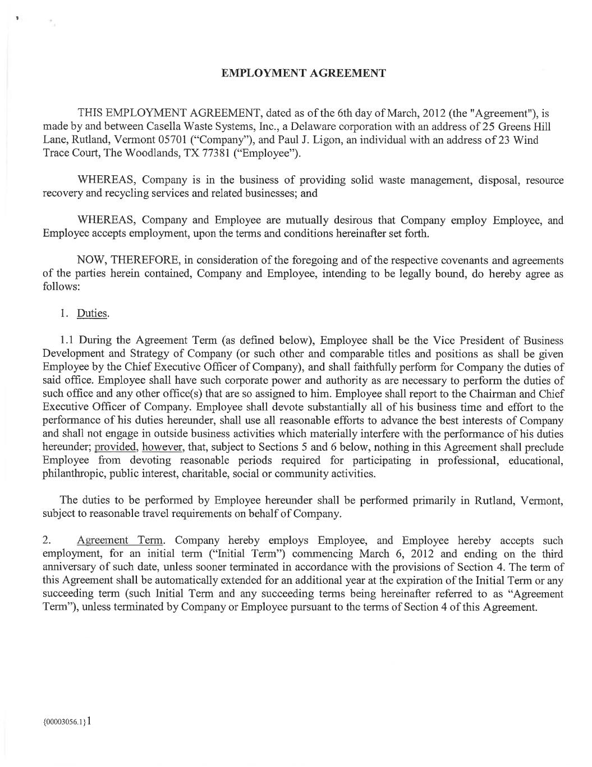
42

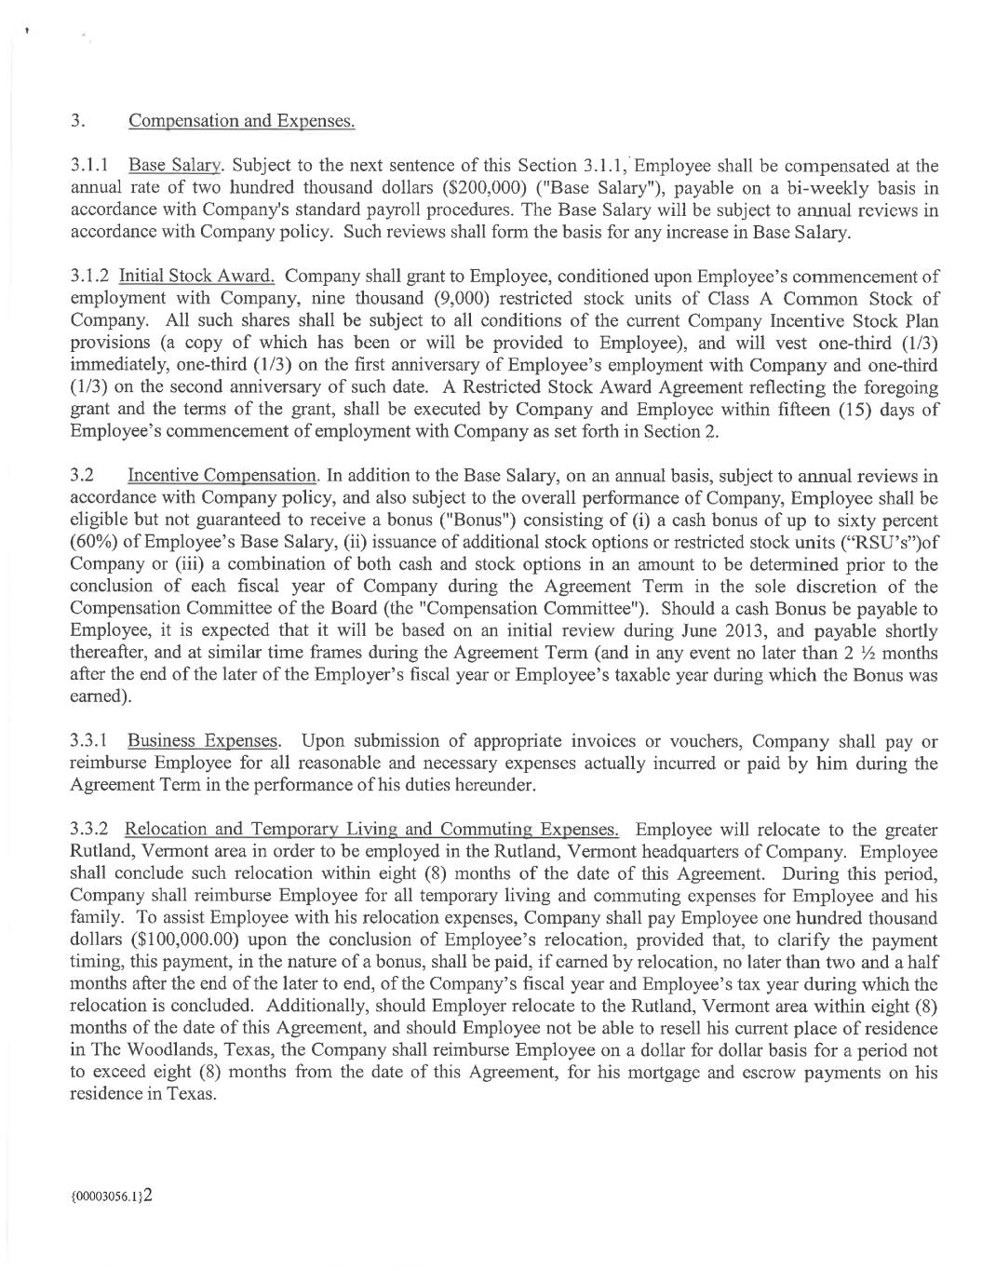

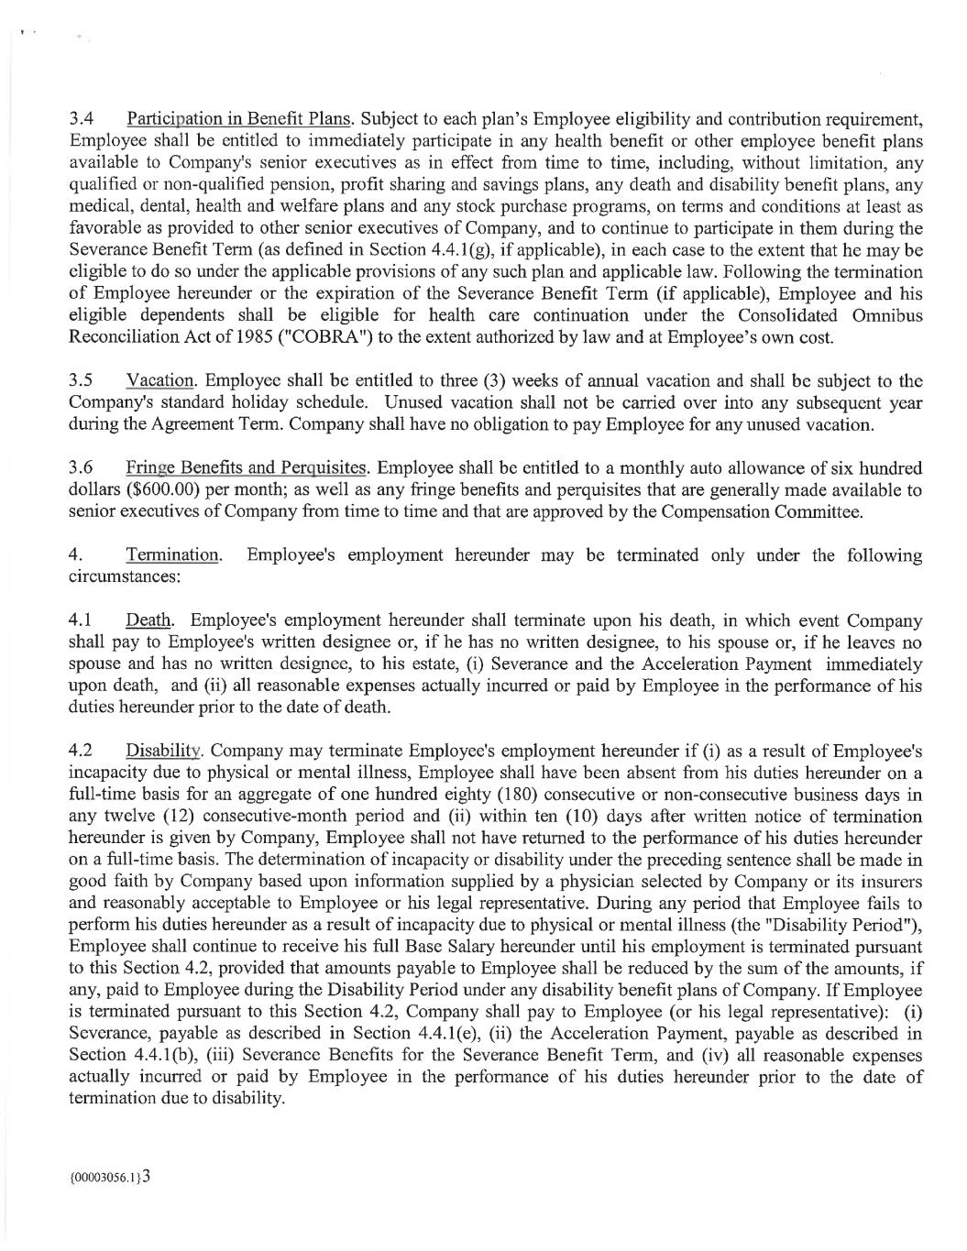

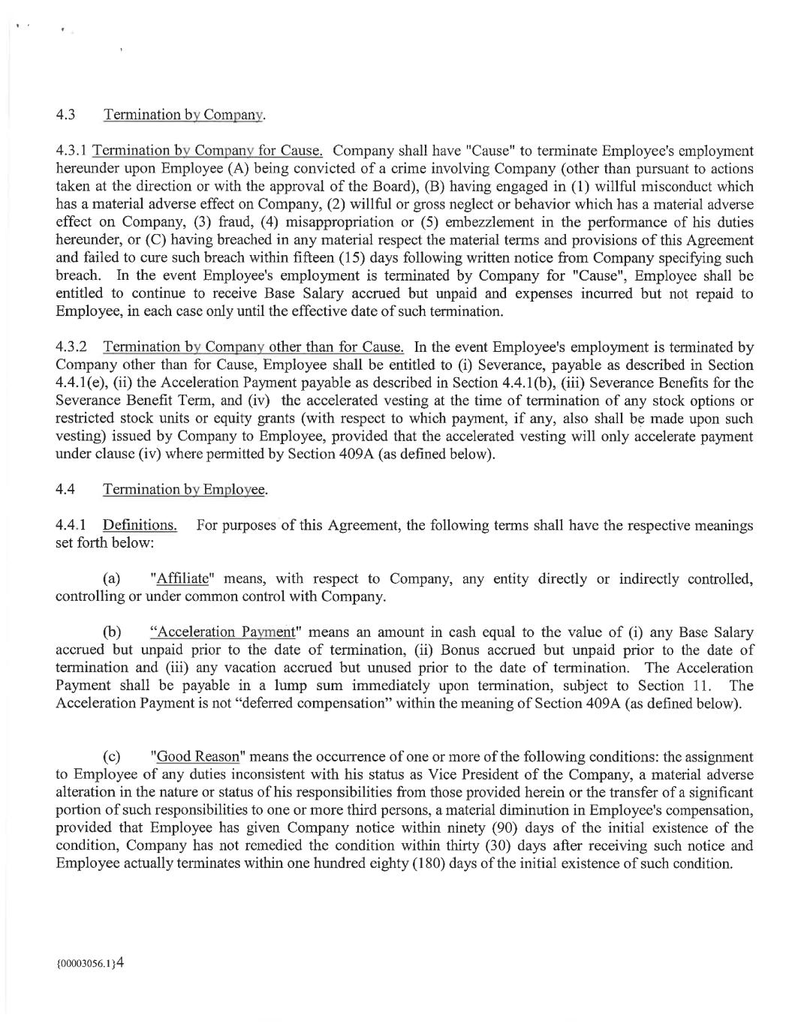

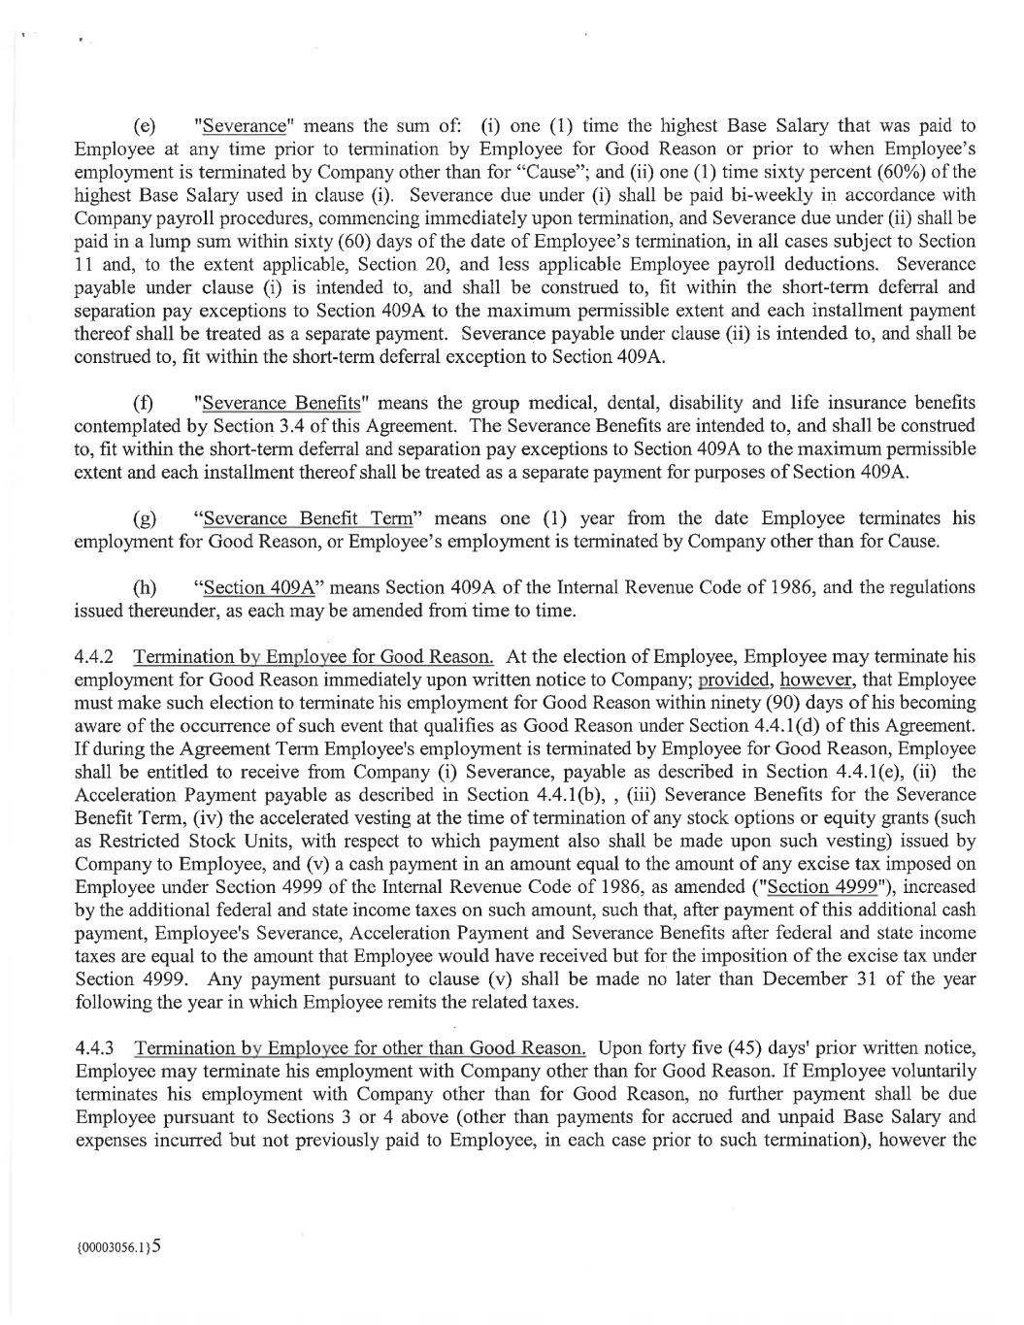

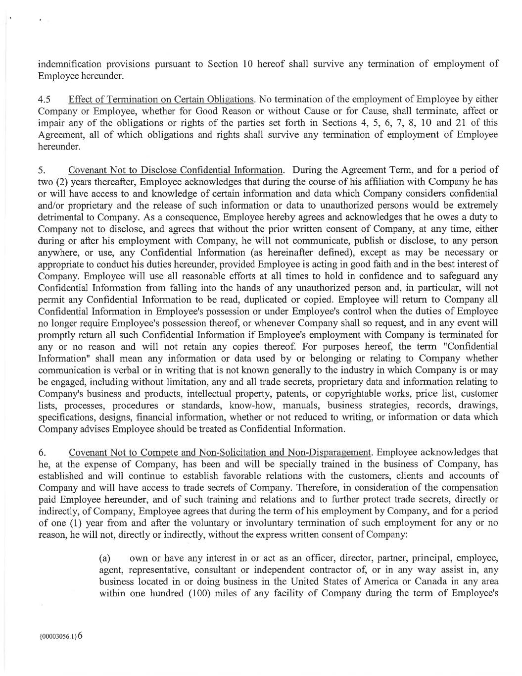

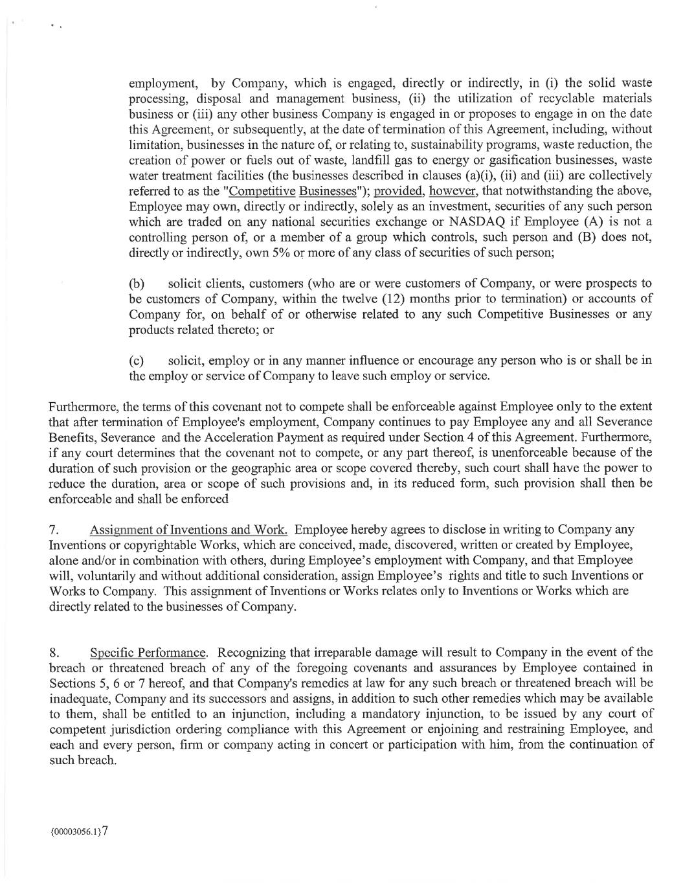

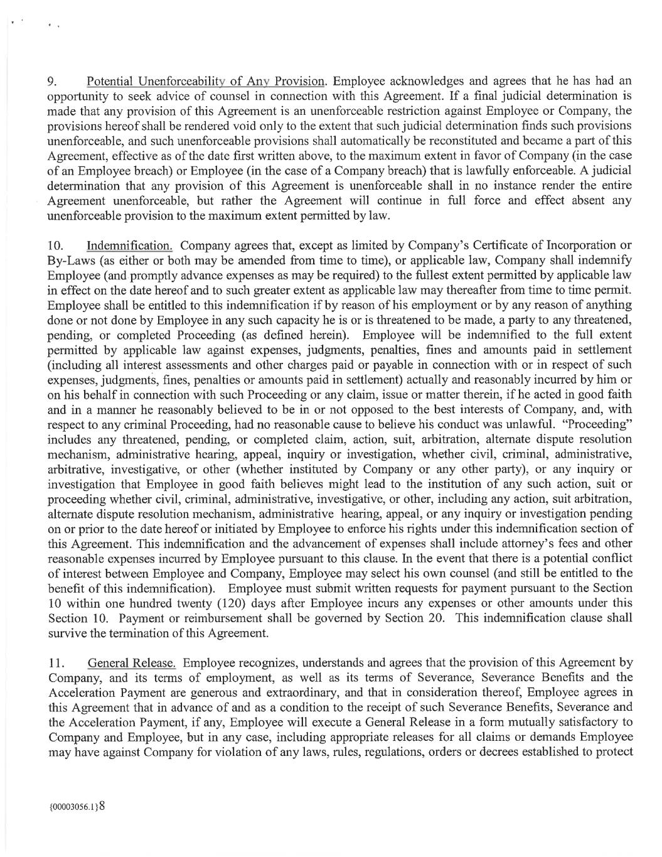

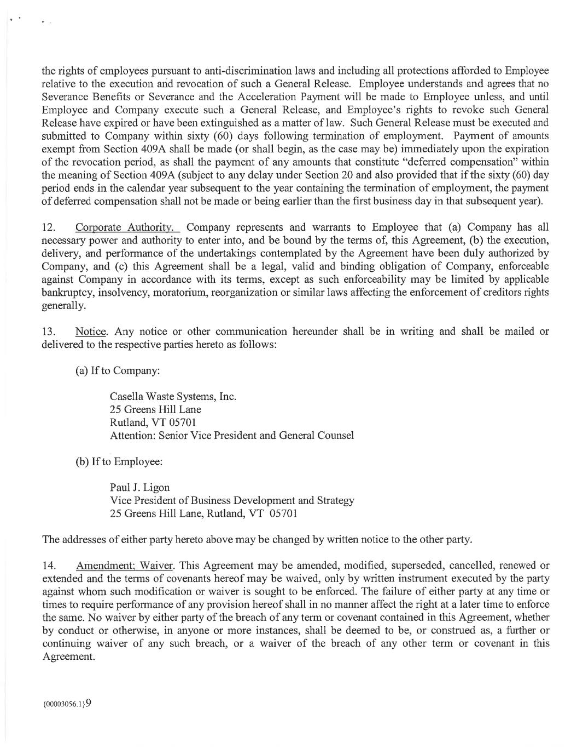

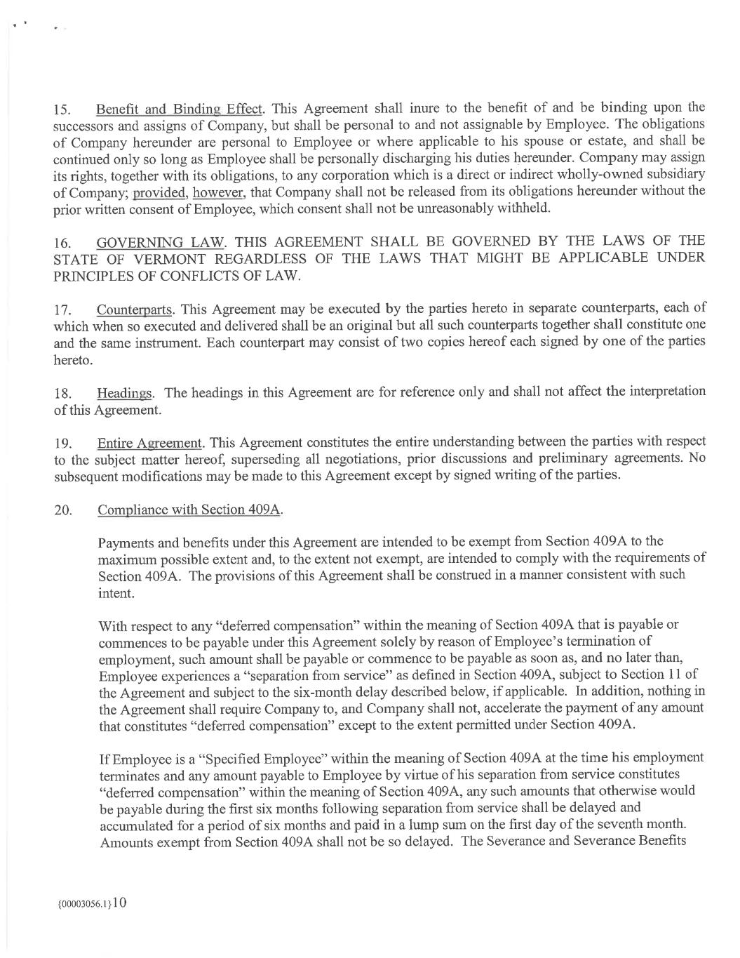

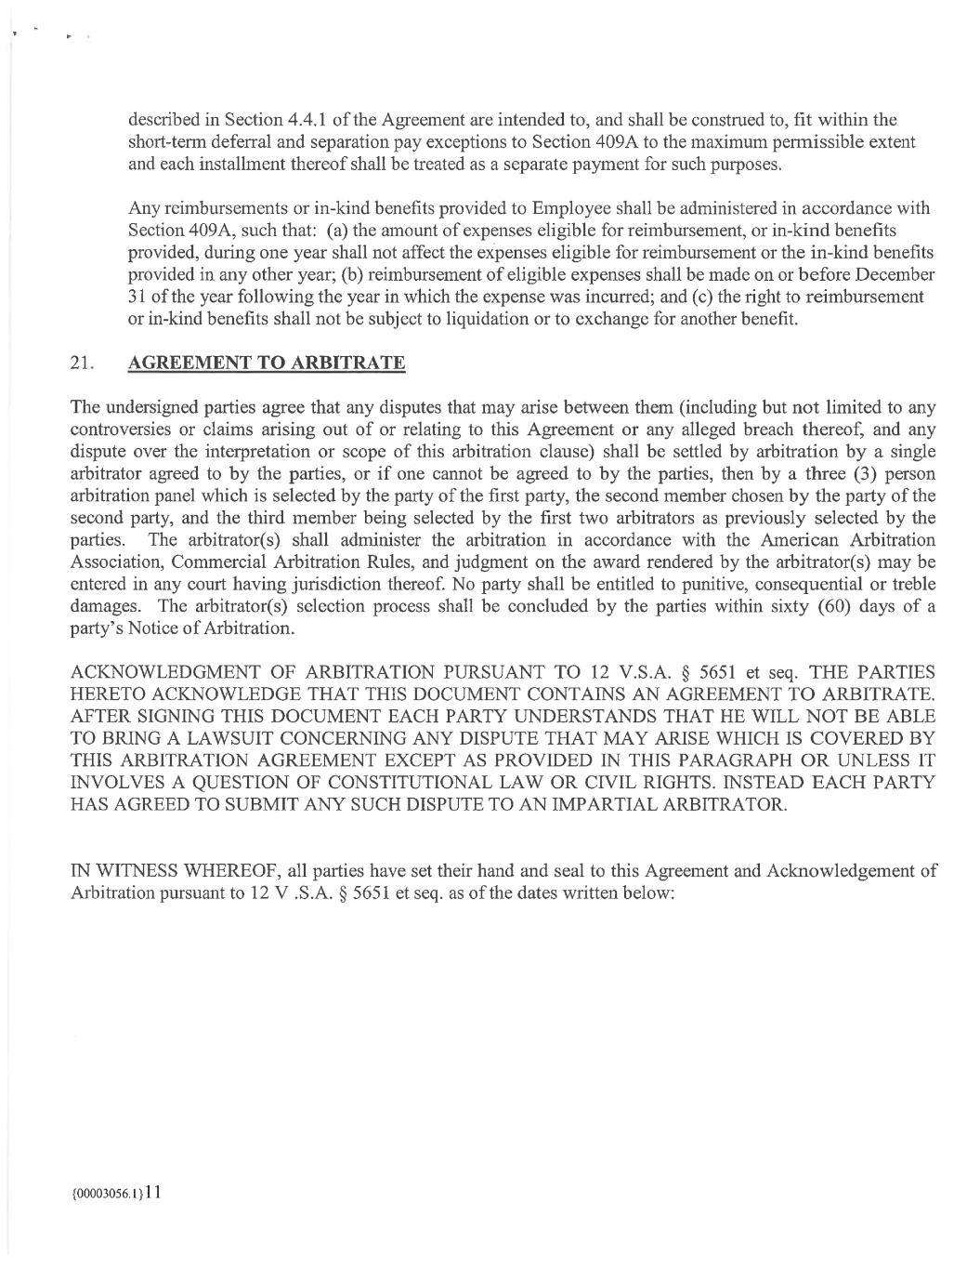

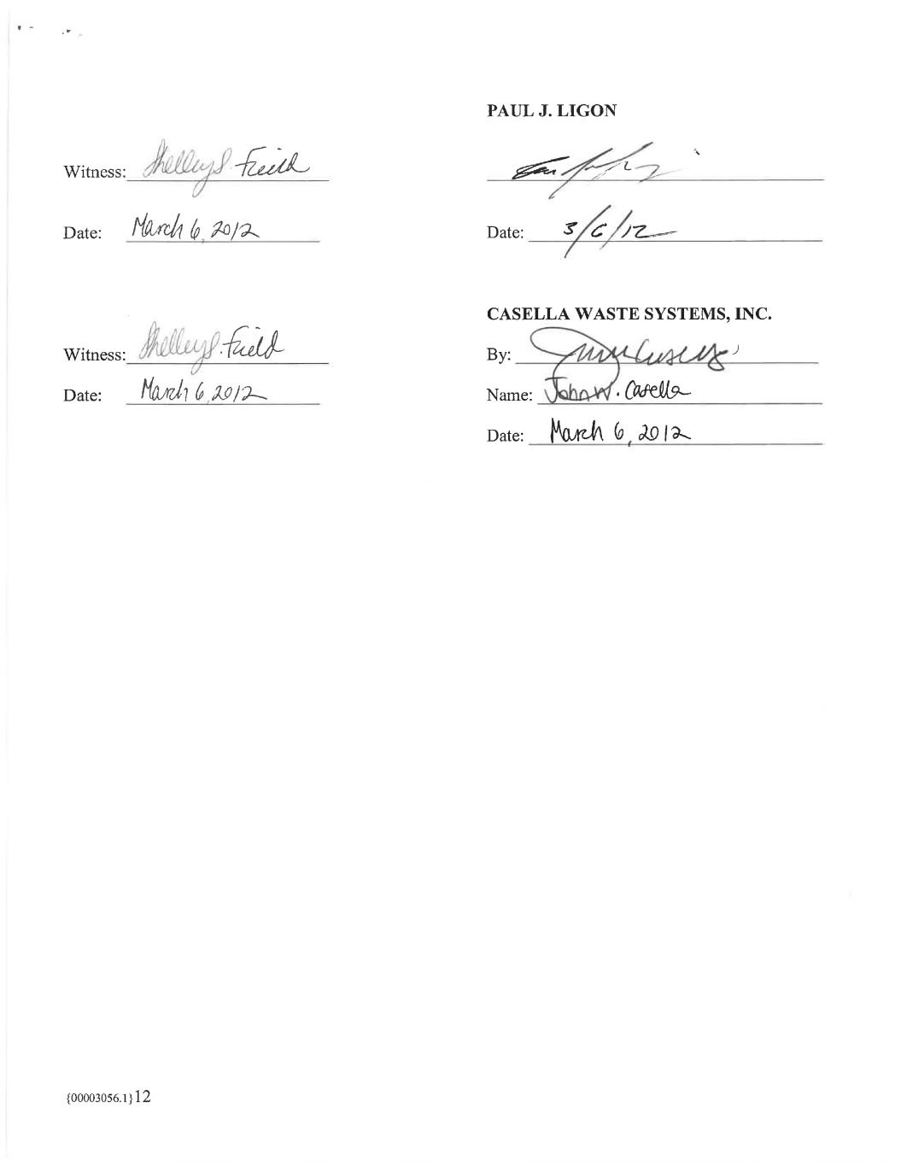

EXHIBIT 31.1
CERTIFICATION
I, John W. Casella, certify that:
1.I have reviewed this Quarterly Report on Form 10-Q of Casella Waste Systems, Inc.;
2.Based on my knowledge, this report does not contain any untrue statement of a material fact or omit to state a material fact necessary to make the statements made, in light of the circumstances under which such statements were made, not misleading with respect to the period covered by this report;
3.Based on my knowledge, the financial statements, and other financial information included in this report, fairly present in all material respects the financial condition, results of operations and cash flows of the registrant as of, and for, the periods presented in this report;
4.The registrant’s other certifying officer and I are responsible for establishing and maintaining disclosure controls and procedures (as defined in Exchange Act Rules 13a-15(e) and 15d-15(e)) and internal control over financial reporting (as defined in Exchange Act Rules 13a-15(f) and 15d-15(f)) for the registrant and have:
a)Designed such disclosure controls and procedures, or caused such disclosure controls and procedures to be designed under our supervision, to ensure that material information relating to the registrant, including its consolidated subsidiaries, is made known to us by others within those entities, particularly during the period in which this report is being prepared;
b)Designed such internal control over financial reporting, or caused such internal control over financial reporting to be designed under our supervision, to provide reasonable assurance regarding the reliability of financial reporting and the preparation of financial statements for external purposes in accordance with generally accepted accounting principles;
c)Evaluated the effectiveness of the registrant’s disclosure controls and procedures and presented in this report our conclusions about the effectiveness of the disclosure controls and procedures, as of the end of the period covered by this report based on such evaluation; and
d)Disclosed in this report any change in the registrant’s internal control over financial reporting that occurred during the registrant’s most recent fiscal quarter (the registrant’s fourth fiscal quarter in the case of an annual report) that has materially affected, or is reasonably likely to materially affect, the registrant’s internal control over financial reporting; and
5.The registrant’s other certifying officer and I have disclosed, based on our most recent evaluation of internal control over financial reporting, to the registrant’s auditors and the audit committee of the registrant’s board of directors (or persons performing the equivalent functions):
a)All significant deficiencies and material weaknesses in the design or operation of internal control over financial reporting which are reasonably likely to adversely affect the registrant’s ability to record, process, summarize and report financial information; and
b)Any fraud, whether or not material, that involves management or other employees who have a significant role in the registrant’s internal control over financial reporting.
Date: April 28, 2023 |  |  | By: /s/ John W. Casella
 |  |  | John W. Casella
 |  |  | Chairman and Chief Executive Officer
 |  |  | (Principal Executive Officer)

EXHIBIT 31.2
CERTIFICATION
I, Edmond R. Coletta, certify that:
1.I have reviewed this Quarterly Report on Form 10-Q of Casella Waste Systems, Inc.;
2.Based on my knowledge, this report does not contain any untrue statement of a material fact or omit to state a material fact necessary to make the statements made, in light of the circumstances under which such statements were made, not misleading with respect to the period covered by this report;
3.Based on my knowledge, the financial statements, and other financial information included in this report, fairly present in all material respects the financial condition, results of operations and cash flows of the registrant as of, and for, the periods presented in this report;
4.The registrant’s other certifying officer and I are responsible for establishing and maintaining disclosure controls and procedures (as defined in Exchange Act Rules 13a-15(e) and 15d-15(e)) and internal control over financial reporting (as defined in Exchange Act Rules 13a-15(f) and 15d-15(f)) for the registrant and have:
a)Designed such disclosure controls and procedures, or caused such disclosure controls and procedures to be designed under our supervision, to ensure that material information relating to the registrant, including its consolidated subsidiaries, is made known to us by others within those entities, particularly during the period in which this report is being prepared;
b)Designed such internal control over financial reporting, or caused such internal control over financial reporting to be designed under our supervision, to provide reasonable assurance regarding the reliability of financial reporting and the preparation of financial statements for external purposes in accordance with generally accepted accounting principles;
c)Evaluated the effectiveness of the registrant’s disclosure controls and procedures and presented in this report our conclusions about the effectiveness of the disclosure controls and procedures, as of the end of the period covered by this report based on such evaluation; and
d)Disclosed in this report any change in the registrant’s internal control over financial reporting that occurred during the registrant’s most recent fiscal quarter (the registrant’s fourth fiscal quarter in the case of an annual report) that has materially affected, or is reasonably likely to materially affect, the registrant’s internal control over financial reporting; and
5.The registrant’s other certifying officer and I have disclosed, based on our most recent evaluation of internal control over financial reporting, to the registrant’s auditors and the audit committee of the registrant’s board of directors (or persons performing the equivalent functions):
a)All significant deficiencies and material weaknesses in the design or operation of internal control over financial reporting which are reasonably likely to adversely affect the registrant’s ability to record, process, summarize and report financial information; and
b)Any fraud, whether or not material, that involves management or other employees who have a significant role in the registrant’s internal control over financial reporting.
Date: April 28, 2023 |  |  | By: /s/ Edmond R. Coletta
 |  |  | Edmond R. Coletta
 |  |  | President and Chief Financial Officer
 |  |  | (Principal Financial Officer)

EXHIBIT 32.1
CERTIFICATION PURSUANT TO 18 U.S.C. SECTION 1350,
AS ADOPTED PURSUANT TO
SECTION 906 OF THE SARBANES-OXLEY ACT OF 2002
In connection with the Quarterly Report on Form 10-Q of Casella Waste Systems, Inc. for the period ended March 31, 2023 as filed with the Securities and Exchange Commission on the date hereof (“Report”), the undersigned, John W. Casella, Chairman and Chief Executive Officer, hereby certifies, pursuant to 18 U.S.C. Section 1350, that, to his knowledge:
(1)the Report fully complies with the requirements of Section 13(a) or 15(d) of the Securities Exchange Act of 1934; and
(2)the information contained in the Report fairly presents, in all material respects, our financial condition and results of operations.
Date: April 28, 2023 |  |  | By: /s/ John W. Casella
 |  |  | Chairman and Chief Executive Officer
 |  |  | (Principal Executive Officer)

EXHIBIT 32.2
CERTIFICATION PURSUANT TO 18 U.S.C. SECTION 1350,
AS ADOPTED PURSUANT TO
SECTION 906 OF THE SARBANES-OXLEY ACT OF 2002
In connection with the Quarterly Report on Form 10-Q of Casella Waste Systems, Inc. for the period ended March 31, 2023 as filed with the Securities and Exchange Commission on the date hereof (“Report”), the undersigned, Edmond R. Coletta, President and Chief Financial Officer, hereby certifies, pursuant to 18 U.S.C. Section 1350, that, to his knowledge:
(1)the Report fully complies with the requirements of Section 13(a) or 15(d) of the Securities Exchange Act of 1934, as amended; and
(2)the information contained in the Report fairly presents, in all material respects, our financial condition and results of operations.
Date: April 28, 2023 |  |  | By: /s/ Edmond R. Coletta
 |  |  | President and Chief Financial Officer
 |  |  | (Principal Financial Officer)

